**Predicting the trends of the Azithromycin consumption for the treatment of infectious diseases in the USA by 2025**

**Team members** - Daniel Asefa, Pranavi Shakkari, Rahul Chowdary Byrapuneni,

Sai Sravanthi Kilari, Sravya Devisetty, Sri Vani Thanniru

Indiana University-Purdue University, Indianapolis, IN 46202, USA

[dasefa@iu.edu](mailto:dasefa@iu.edu), [pshakkar@iu.edu](mailto:pshakkar@iu.edu), [rabyra@iu.edu](mailto:rabyra@iu.edu), [sakilari@iu.edu](mailto:sakilari@iu.edu), [sdeviset@iu.edu](mailto:sdeviset@iu.edu), [sthannir@iu.edu](mailto:sthannir@iu.edu)

**Abstract:** This project is a predictive analysis that predicts the consumption of azithromycin drugs in the country USA by 2025. We included the GWAS data in the study to validate the resistance of Neisseria gonorrhoeae to the azithromycin drug. We did various visualizations and data analysis techniques to filter and predict the outcomes of given data. In our analysis, Mancova is done to understand the relation between the Top 10 units of Genomic data, and we observed that the bacterial strains show the resistance to the Azithromycin. This analysis is considered our substantial method to reject the null hypothesis. Our prediction is there will be an increase in azithromycin consumption by the year 2025 in the USA.

**Keywords:** GWAS(Genome-wide association studies), Azithromycin, Neisseria gonorrhoeae, Consumption, Resistance, Analysis, USA, Minimum Inhibitory Concentration.

**1. Project scope:**

**1.1 Introduction:**

Azithromycin is a broad-spectrum antibiotic prescribed for many bacterial infections, majorly in pulmonary conditions, genital, and enteric infections. According to the cohort study done by the *Washington School of Medicine*,2018. They assessed several antibiotics and stated Azithromycin is one of the most prescribed antibiotics in the USA. In the current situation, as mentioned in “*rationale for Azithromycin in covid-19*”, there is a significant rise in the usage of Azithromycin due to post and present COVID-19 complications such as respiratory distress, throat infections. Past studies like *“Mass distribution of Azithromycin for trachoma”* show that excessive Azithromycin usage may cause resistance for specific bacteria like Escherichia coli, streptococcus pneumonia, and many other gram harmful bacteria that cause several infections. A news article published on market watch named *“Azithromycin market trends”* highlighted that there would be a hike in the usage of Azithromycin consumption by 2025. In this study, we will analyze and study the consumption of Azithromycin with the involvement of genomic data, consisting of *Neisseria gonorrhoeae* unities. We will evaluate the resistance of those strains. Using multiple programming tools and descriptive statistics, we evaluate factors associated with the consumption of Azithromycin in the USA.

**1.2 Aim:**

This study aims to determine the variables that contribute to increase or decrease Azithromycin consumption to treat infectious diseases. Using various genomic and CSV data analysis tools and visualization techniques, display predominant factors for drug consumption and predict the trends of Azithromycin consumption in the USA by 2025.

**1.3 Objectives**:

* To find the relation between the top 10 genomic units and azithromycin resistance.
* To Correlate Azithromycin resistance and its Minimum inhibitory concentration values.
* To find out the azithromycin consumption in the USA by the year 2025.

**1.4 Research Hypothesis:**

**Null Hypothesis:** There is no association between the genomic factors and Azithromycin resistance to predict its consumption.

**Alternate Hypothesis:** There is a significant association between the genomic factors and Azithromycin resistance to predict its consumption.

**1.5 Purpose:**

The purpose of the study is to identify, test, and investigate different units of the Bacterium Neisseria Gonorrhoea associated with Azithromycin resistance and predict the increase or decrease in the consumption of Azithromycin to treat bacterial infections by 2025 in the United States. The current trend in the COVID-19 situation is making the patients consume more azithromycin to treat their conditions. So, with the bacterial strains present, we measure the resistance and consumption of azithromycin that contributes information regarding the drug usage.

**2. Methodology:**

**2.1 Project steps:**

The focus of this project originated considering the ever-growing concern of bacterial diseases around the globe. We are interested in finding out the benefit of using Azithromycin. Factors associated with the rate of consumption, such as adaptability, variants of infectious diseases, immunity improvements, side effects, are examined. The following methods and procedures are used to predict the consumption of Azithromycin in 2025.

1. Explore the data efficiency, research literature reviews, and discuss the importance and relevance of the work.
2. Investigate the research question and develop the null and alternative hypotheses.

3. Data collection, loading, and extraction. (Python and MySQL)

4. Data transformation, cleaning, processing, and extraction applying tools including MySQL, Python, Tableau, and A.I.

● Data cleaning using (Python, MySQL, and Machine Learning)

● Exploratory analysis and data modeling

● Apply descriptive statistics to do hypothesis testing, test statistics, correlation and regression, the margin of errors, and confidence interval.

● Perform MANCOVA(Statistical Testing) test to see the relationship between variables.

● Perform logistic regression among the factors to identify the predominant factor for the consumption of the drug.

● Analyze the genomic data using python, CSV, GWAS data.

● Data visualization using different tools Tableau will display a heatmap to show the correlation between the variables.

5. Display the findings.

**2.2 Original Responsibilities of Team members:**

Below is the list of original responsibilities of the team members we had for the project.

|  |  |  |
| --- | --- | --- |
| **Team Members** | **Background** | **Responsibility** |
| Daniel Asefa | Bachelor of Science in Informatics | Planning, Initiation, and organizing the project. Data collection, MySQL, Python, R, coding, descriptive statistics, tableau visualization, Test statistics, and ANOVA |
| Sri Vani Thanniru |  | Follow project communication, Data cleaning, and transforming, MySQL, Python coding, statistical analysis, genome analysis |
| Pranavi Shakkari | Bachelor of Dentistry, new to SQL, Python, Tableau. | Follow project schedule and deliverables timeline, MySQL, Python Test statistics, and/or ANOVA |
| Rahul Chowdary Byrapuneni | Doctor of pharmacy, new to SQL, Python, and Tableau. | Study the objective of the project purpose and literature reviews, MySQL, Python, coding, machine learning integration, Test statistics and/or ANOVA and MANCOVA |
| Sravya Devisetty | Bachelor of Dentistry, new to SQL, Python, Tableau. | Developing hypothesis, the Study deliverables consistency and scope, MySQL, Python, coding, machine learning integration, |
| Sai Sravanthi Kilari |  | Revising, analyzing, debugging results, MySQL, Python coding. |

**2.3 Actual Contributions from the Team Members:**

Initially, we did a decent job at splitting down tasks to function as effectively as possible. However, owing to unexpected improvements and greater knowledge of each team member's skills, the above table did not accurately represent each team member's responsibilities, and the use of GWAS data in our analysis has had a significant effect on team members' responsibilities. Below are the actual contributions of the team members,

|  |  |  |
| --- | --- | --- |
| **Team Members** | **Background** | **Responsibility** |
| Daniel Asefa | Bachelor of Science in Informatics | Data collection and cleaning, import to MySQL database.SQL and python coding, Tableau, MANCOVA. |
| Sri Vani Thanniru |  | Descriptive Statistics, Visualizations of metadata, Python coding. |
| Pranavi Shakkari | Bachelor of Dentistry, new to SQL, Python, Tableau. | Importing GWAS data, building Machine Learning Models, coding, statistical modeling, Python coding. |
| Rahul Chowdary Byrapuneni | Doctor of pharmacy, new to SQL, Python, and Tableau. | Visualizations of metadata, project presentation, Python coding, MANCOVA. |
| Sravya Devisetty | Bachelor of Dentistry, new to SQL, Python, Tableau. | Developing hypothesis, MySQL, Python, coding, machine learning models, MANCOVA, building Machine Learning Models of GWAS data. |
| Sai Sravanthi Kilari |  | Revising, analyzing, debugging results, MySQL, Python coding, MANCOVA, the Study deliverables consistency and scope |

**2.4 Project challenges:**

Every step in the project is challenging, and we tried to sort them out step by step. Our first and major challenge is studying and performing the GWAS study. Though most of us are from a medical background, we cannot handle the GWAS data. It took three weeks to understand the GWAS data and to integrate it with the Metadata. As we are from a medical background, we felt challenged in handling SQL and python in the project.

It took some time to figure out what the column ‘Group’ meant. We looked at the dataset owner Nicole Wheeler's papers to see if the column Group was listed. We couldn't find any reference to it. It is later resolved after contacting her through an email.

We made some mistakes in the analysis part and learned through them. The time period is challenging for us throughout the project. It is due to the other subjects’ assignments and projects. In the final, we initially did the MANOVA, where we did not find any significant output. So, we transferred to MANCOVA as suggested by Professor Saptarshi Purkayastha, which helped us reject a null hypothesis and prove our original hypothesis.

**3. Data Collection**

There are four different data frames in the form of CSV and GWAS data found in Kaggle. <https://www.kaggle.com/nwheeler443/gono-unitigs?select=metadata.csv>. These data provide antibiotic resistance in bacteria, specifically Neisseria gonorrhoeae, across the world.

For his project, we have used two datasets;

1. CSV data “metadata.csv” and
2. GWAS data “azm_rs_gwas_filtered_uniting.Rtab”

**4. Data Extraction and Storage**

**4.1 Data Extraction**

As we have two different datasets, CSV and GWAS, we used multiple methods to perform data cleanup, such as removing incomplete columns and values, reorganizing, and transforming data, which can be achieved using excel, python. In addition, with the help of packages, python libraries, and MySQL environment using database definition and manipulation languages.

On the genomic data-specific processing and quality check can be achieved via methods of Bioconductor packages techniques.

**Metadata:** consists of 3700 rows and 31 columns, and those attributes related to Azithromycin were retained, and others are removed.

**GWAS(Genome-Wide Association Studies) Data:** Consists of 3972 columns and 515 rows of units of Neisseria gonorrhoeae bacteria with 0 is mutation absent, and 1 is mutation present. The GWAS data is changed from Rtab to CSV file and uploaded to the jupyter notebook of python.

The attributes we selected are:

-Sample_id

Azm_mic: Azithromycin Minimum Inhibitory Concentration

NG_MAST: *N. gonorrhoeae* Multi Antigen Sequence Typing

Azm_sr: Azithromycin Resistance

-517 columns of GWAS data

**4.2 Data Cleaning:**

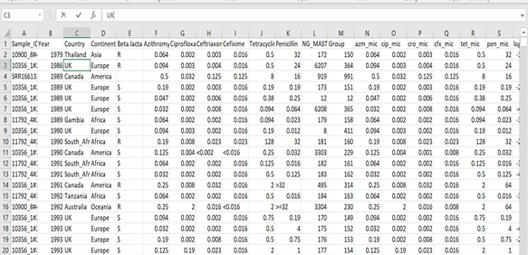

**Fig: Original metadata.**

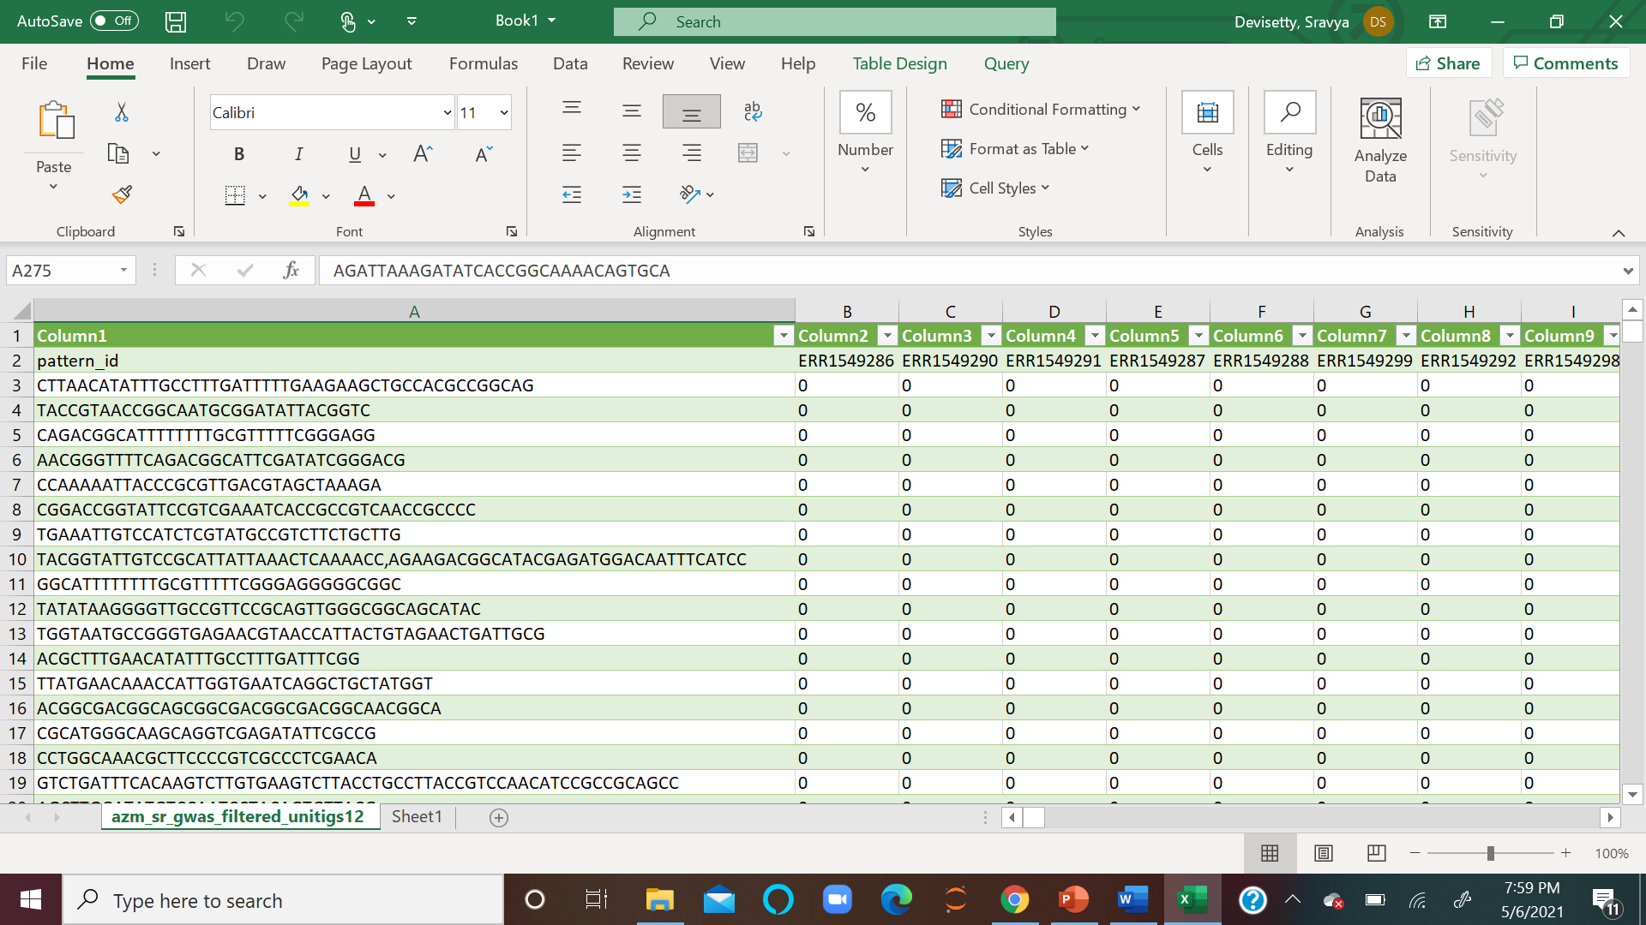

**Fig: Original GWAS Data.**

Initial cleaning of metadata is performed in SQL, and columns related to Azithromycin and rows related to the USA were retained while others are dropped.

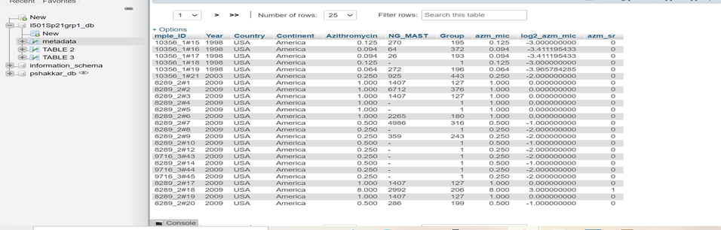

**Fig: metadata imported to MySQL**

The GWAS data is transposed in Excel to match the sample_id of the GWAS data with the patten_id of metadata.

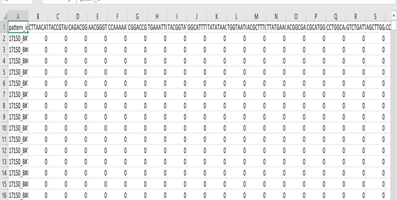

**Fig:** **GWAS Data**

**4.3 Data Import into Python**

Once the attributes are cleansed in Excel, from a shared database “I501Sp21grp1_db” in phpMyAdmin, the data frame is connected to the Jupyter notebook accordingly by providing access for users/ project team members.

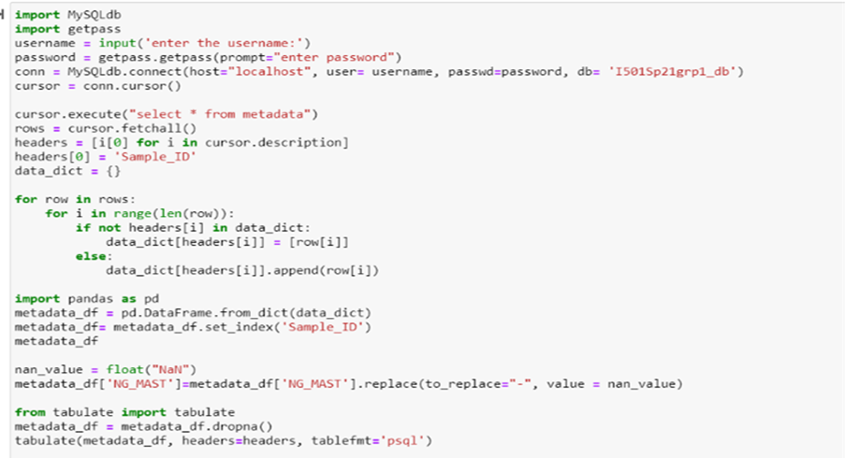 **Fig: import data from MySQL to Python**

**4.4 Further Data Cleaning in python**

Before starting the data cleaning process, we understood each attribute from the project “Predicting antibiotic resistance in gonorrhea” by Nicole Wheeler. We contacted the author to clarify some features such as “azm_mic” and “Azithromycin,” which have similar values and refers to azithromycin minimum inhibition concentration. Therefore, we drop columns Country, Continent since all the values are the same. Drop column azm_mic since it is the same as column Azithromycin.

The null values are; hence found only in the column NG_MAST ( *N. gonorrhea* multi-antigen sequence typing), which is irrelevant to our project. After dropping the column NG_MAST, there were no null values; therefore, we did not have to drop any rows or use either mean mode to fill any null value.

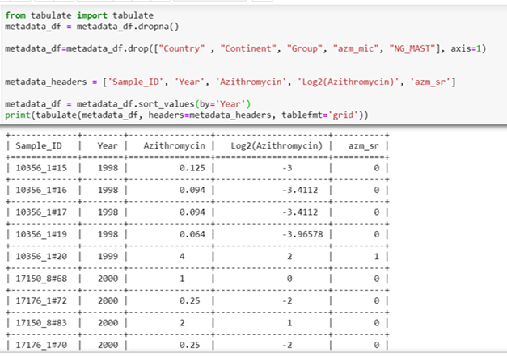**Fig: cleaned data using python.**

**5. Data Analysis:**

Python integrated with Machine Learning was employed to analyze the data.

**5.1 The results from testing the normality of the metadata:**

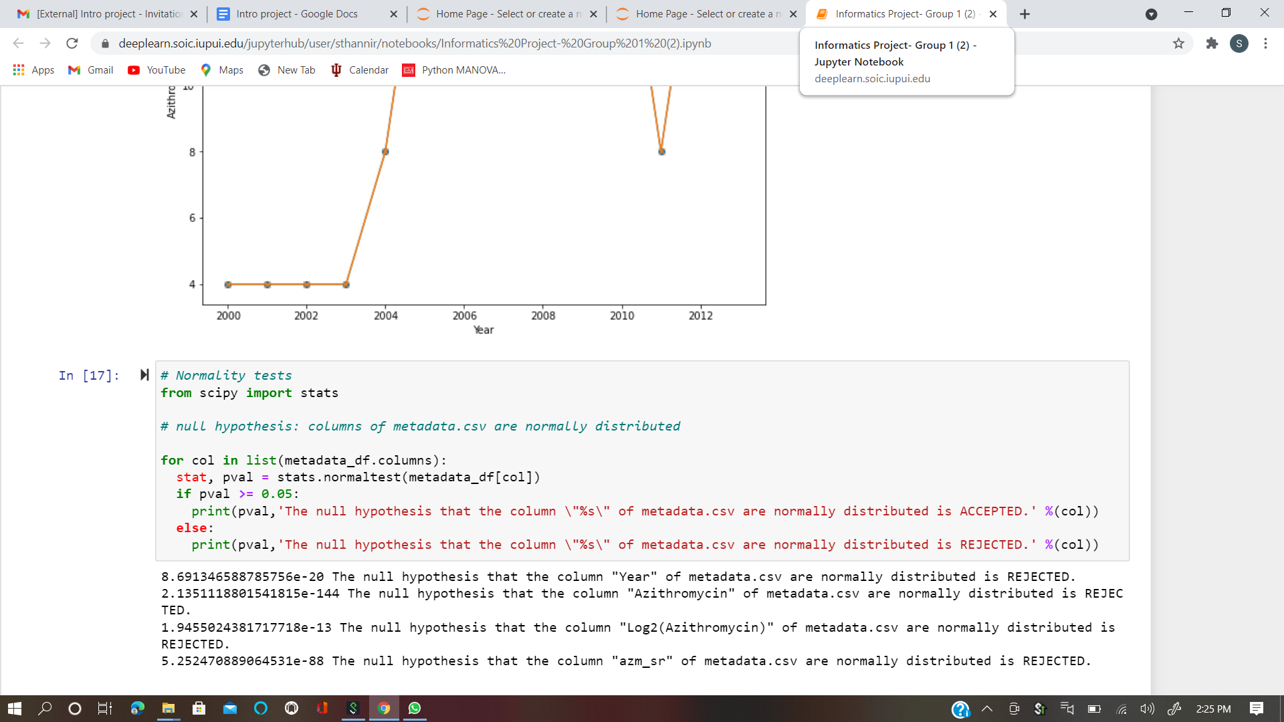

**5.2 Correlation among the attributes.**

To check for the correlation among the various attributes in metadata.csv, we plotted a correlation matrix. We have found that azm_sr and Azithromycin(which is the minimum inhibitory concentration) have a slight positive correlation of 0.37

**CORRELATION:**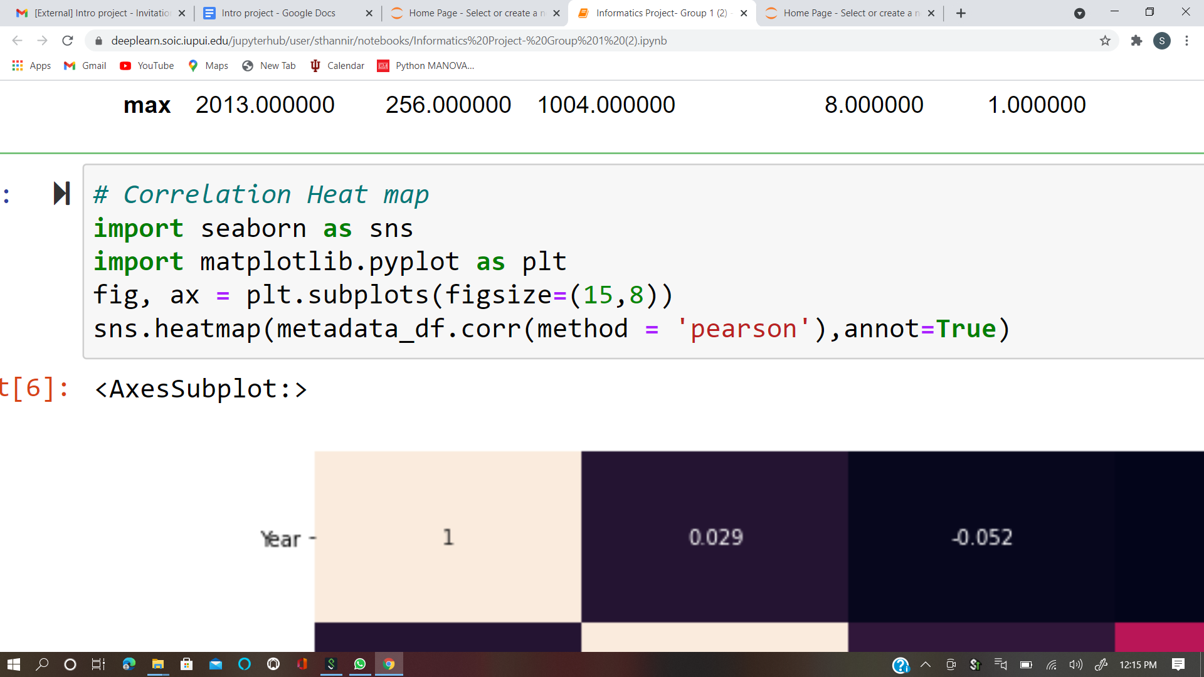

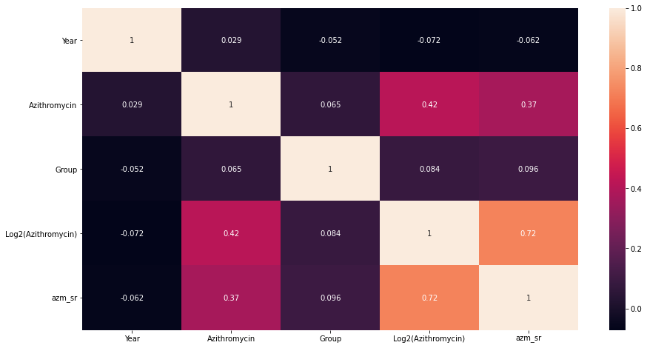

**DESCRIPTIVE STATISTICS:**

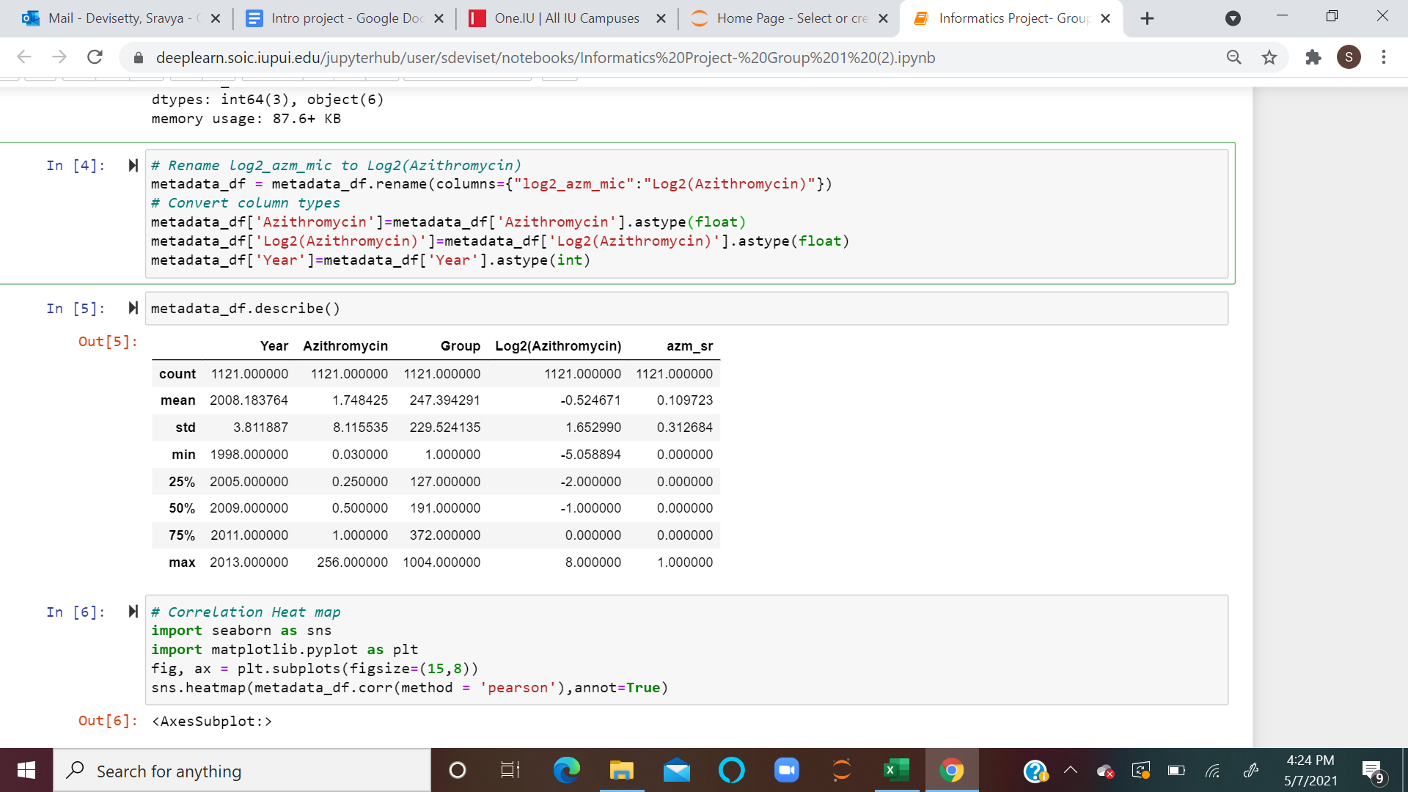

To understand the data better, we plotted boxplots to analyze the distribution of the data.

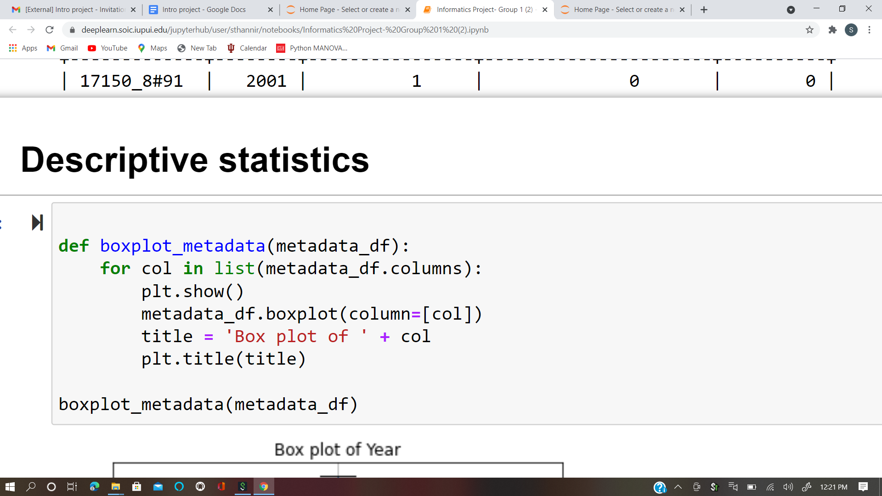

**Before Removing Outlier:**

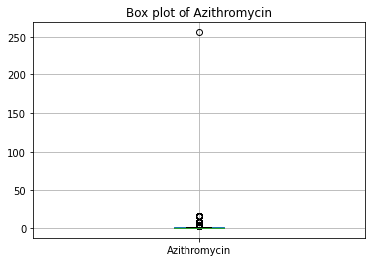

We identified an outlier in the column Azithromycin, where the value is greater than 250 in only 1 year( 2012) which is insignificant, hence we worked on removing the outlier.

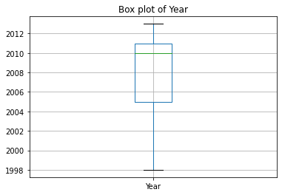

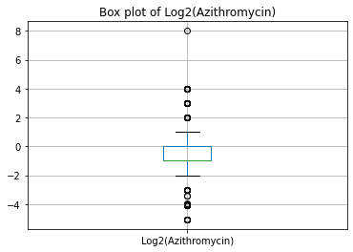

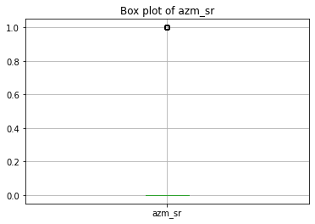

**AFTER REMOVING OUTLIER:**

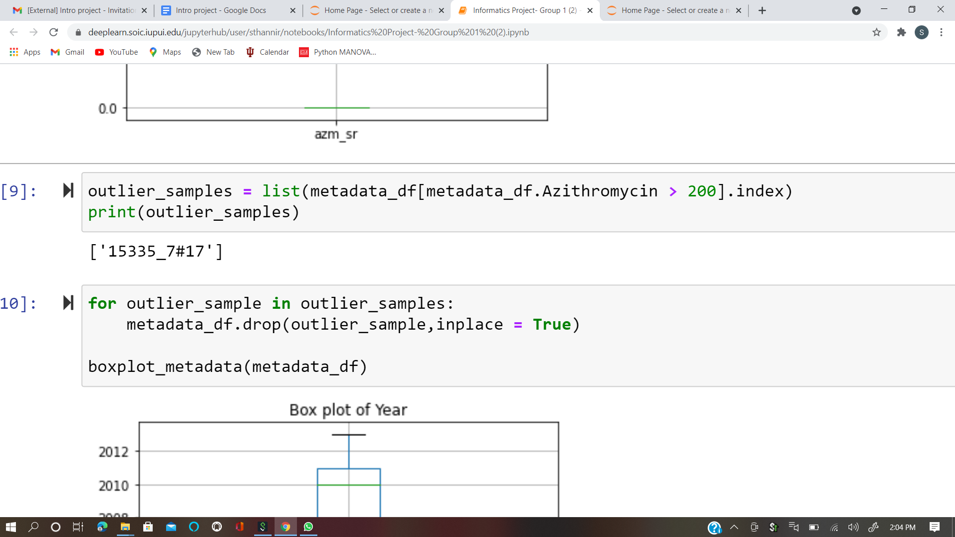

 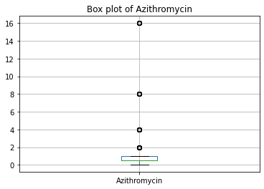

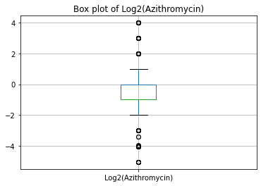 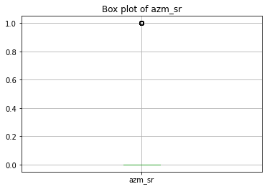

**5.3 Importing GWAS data:**

We used pandas dataframe to import GWAS data into python.

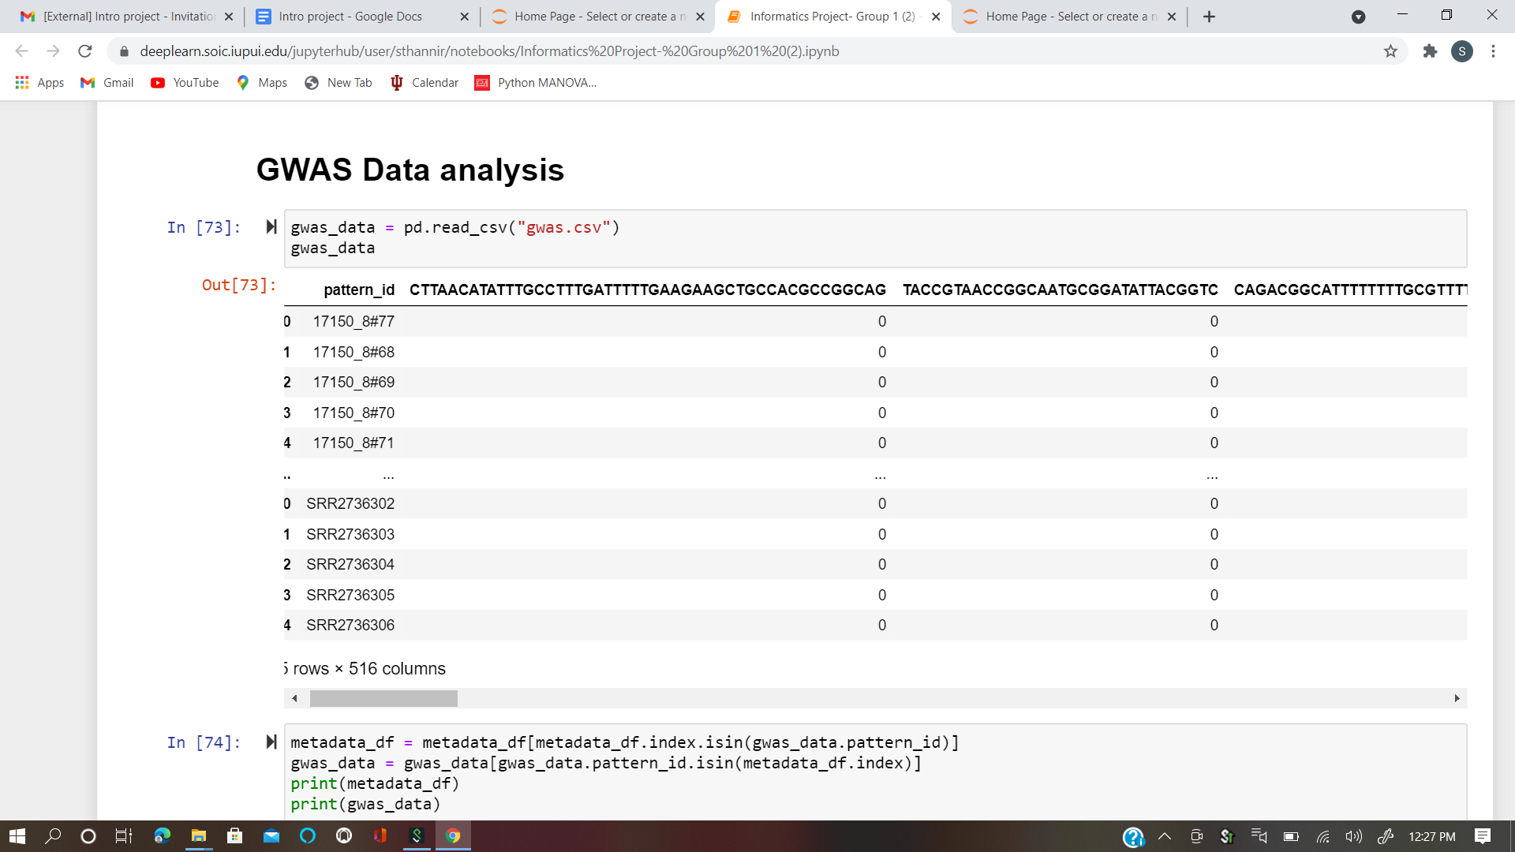

**5.4 Integrating the GWAS data with Metadata.**

The sample id’s of the transposed GWAS data is integrated to match the pattern id’s of metadata.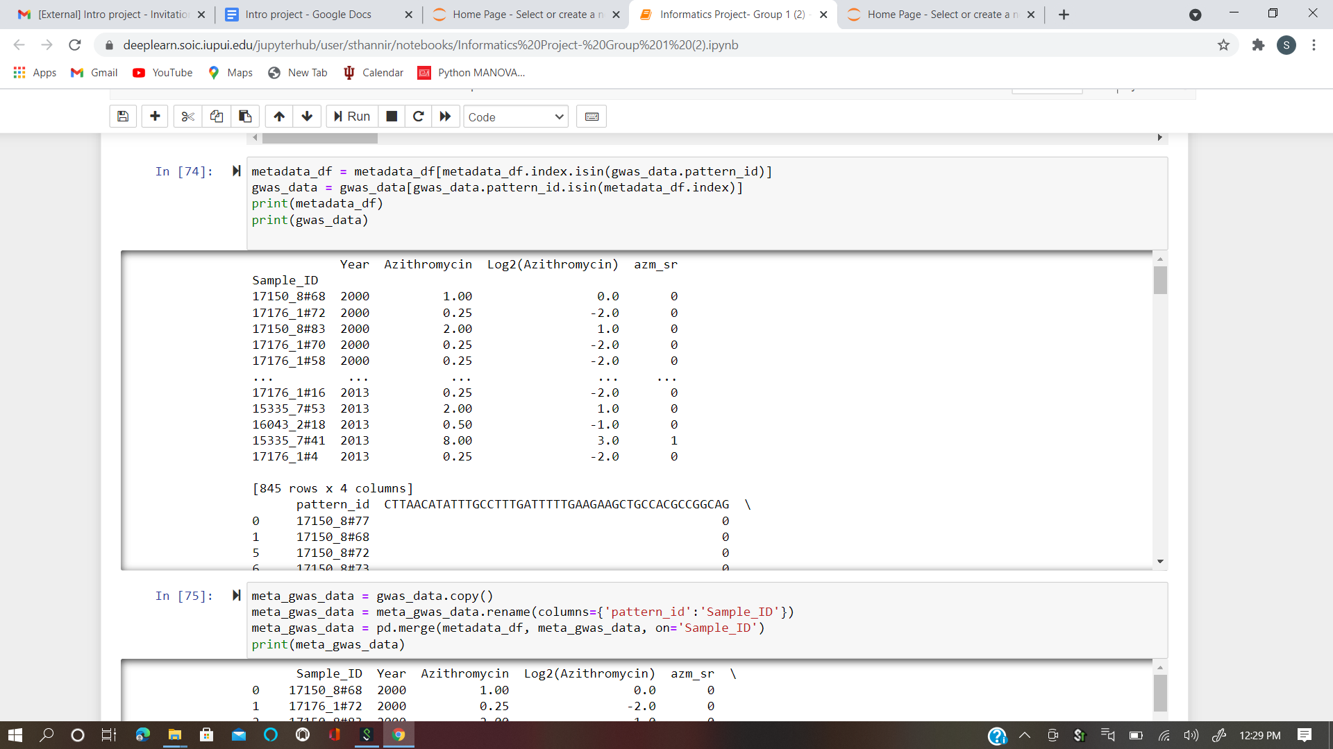

**MACHINE LEARNING MODELS TO IDENTIFY THE TOP FEATURES/DNA BASES OF GWAS DATA:**

The Data Analysis was done by building Machine Learning Models. These machine learning models identified the top 5 positive and top 5 negative DNA sequences that influence the resistance of the bacteria to the drug Azithromycin. In order to build the ML models, all the columns of the GWAS data have been considered into ‘X’, and Azithromycin Resistance column (azm_sr) from the metadata was taken into ‘Y’. The train_test_split values were 80:20, which means that 80% of the data is trained while 20% of the data was used for testing.

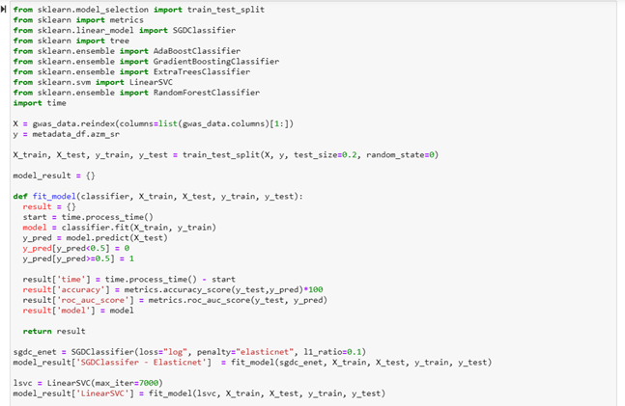

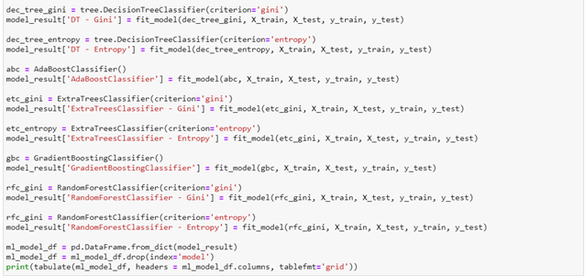

**Fig - 5.1: Training the data**

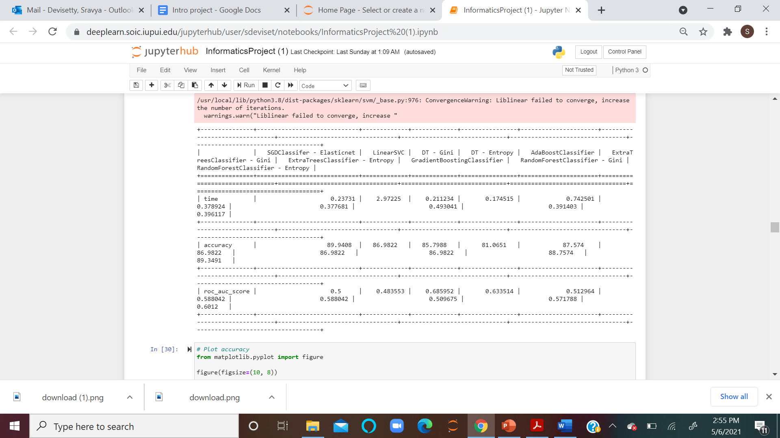

**Fig - 5.2: Time is taken, Accuracythe the , ROC Scores of the data.**

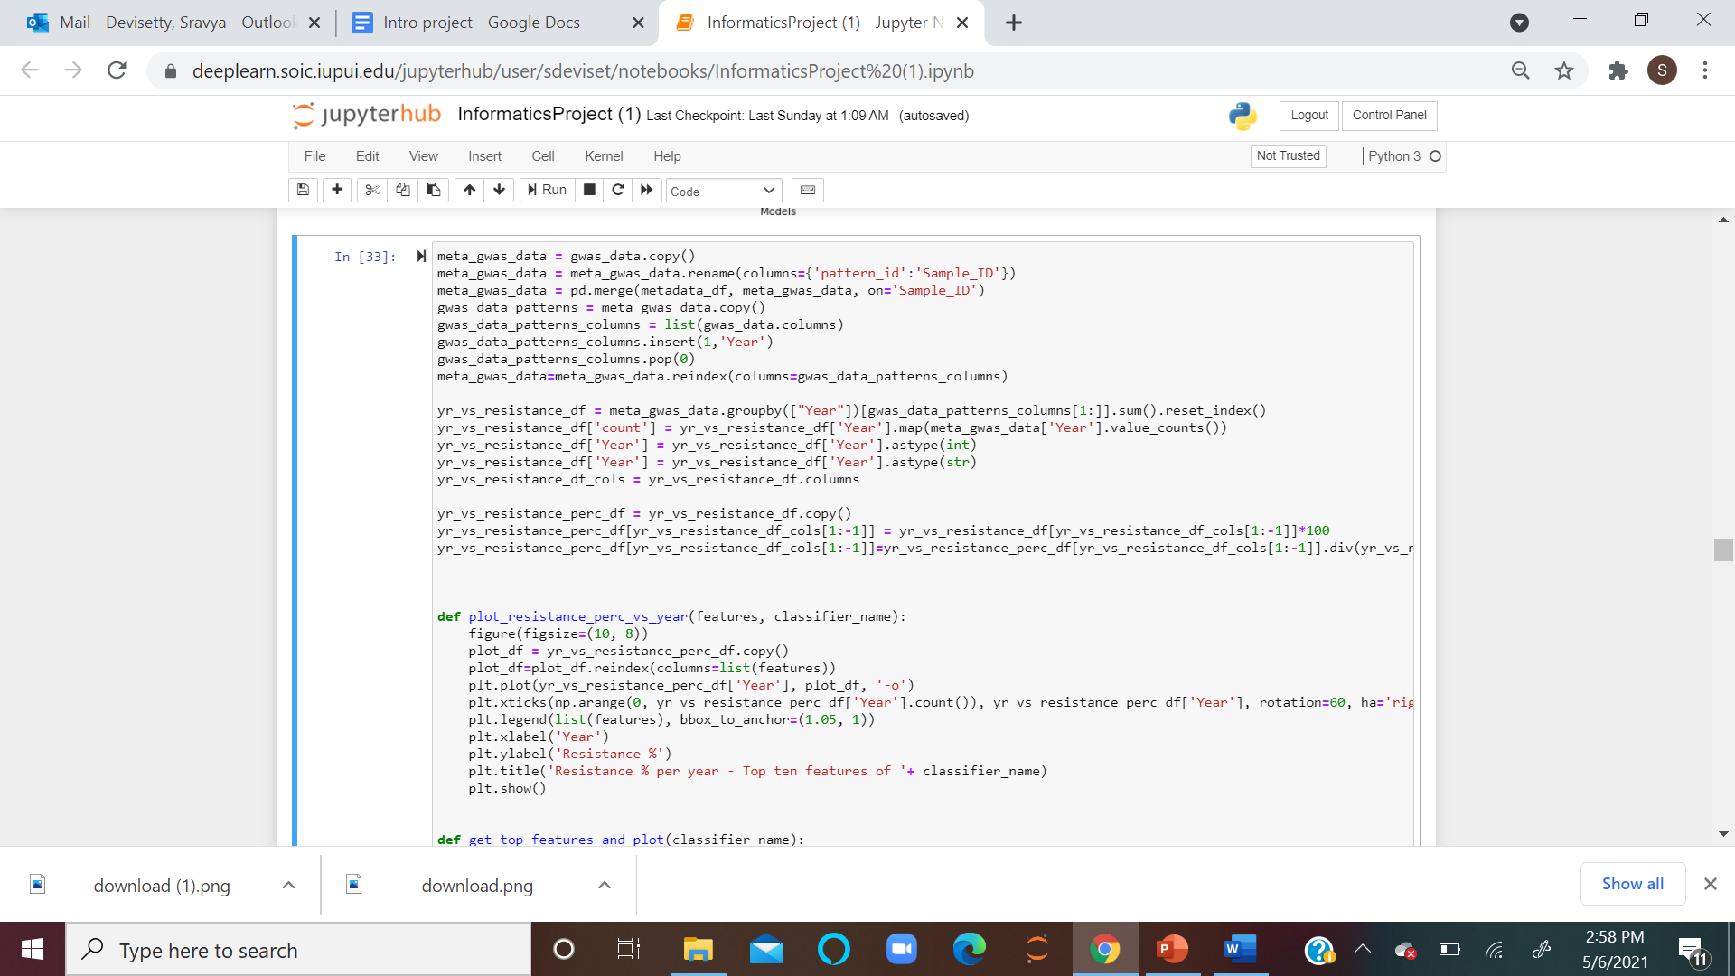

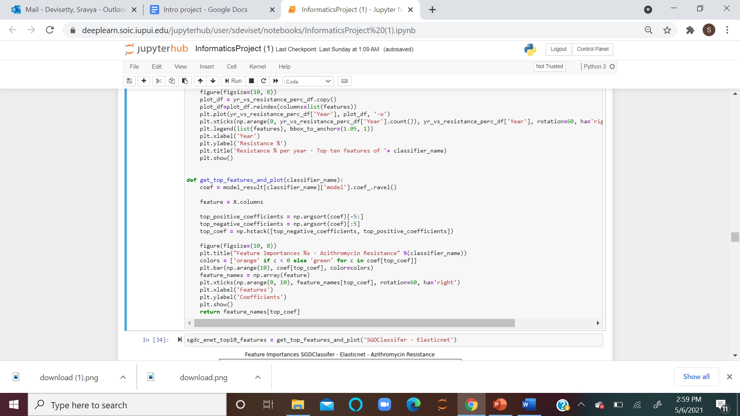

**Accuracy % of models:**

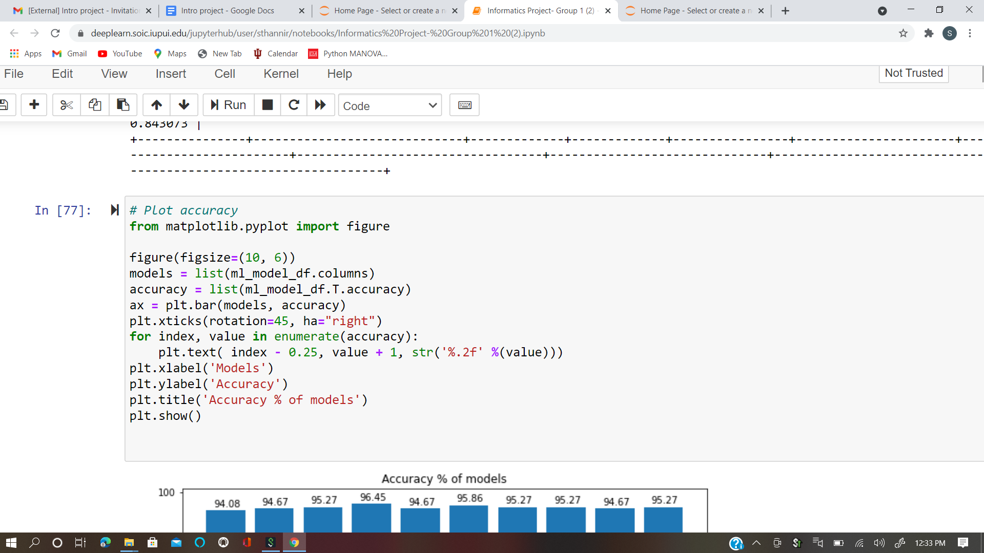

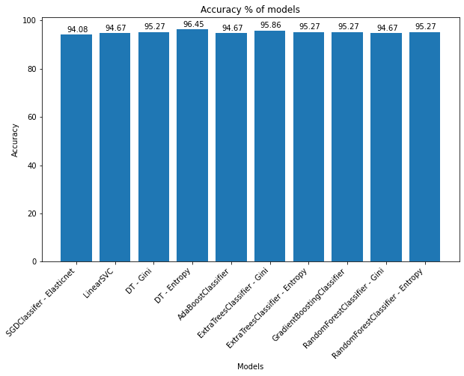

**Fig - 5.3: Accuracy % of models**

The above bar plot shows the accuracy percentage of all the classifier models used and DT - Entropy shows the highest accuracy value of 96.45% among all the others.

**Time response by models:**

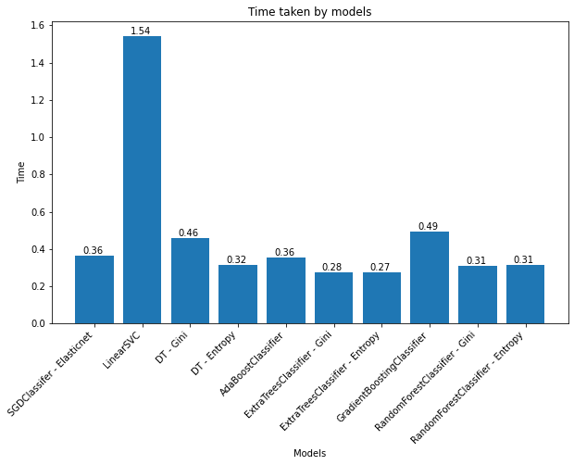

**Fig - 5.4: Time response by all models**

The above bar plot shows the time taken by each classifier model and shows that ExtraTressClassifier - Entropy took less time i.e - 0.27sec when compared to all other models.

**ROC values of models:**

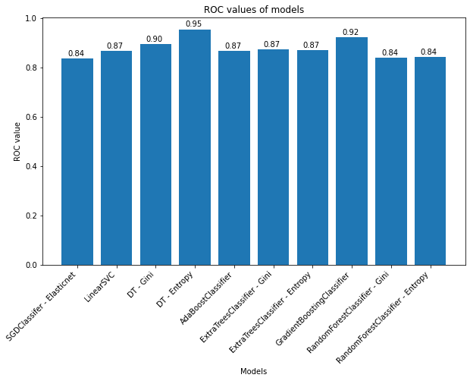

**Fig - 5.5: ROC values of all models**

The above bar plot is drawn to show the ROC values of all the classifier models used and it is clear that DT - Entropy gives the highest value i.e - 0.95, among all other models.

**STOCHASTIC GRADIENT DESCENT CLASSIFIER:**

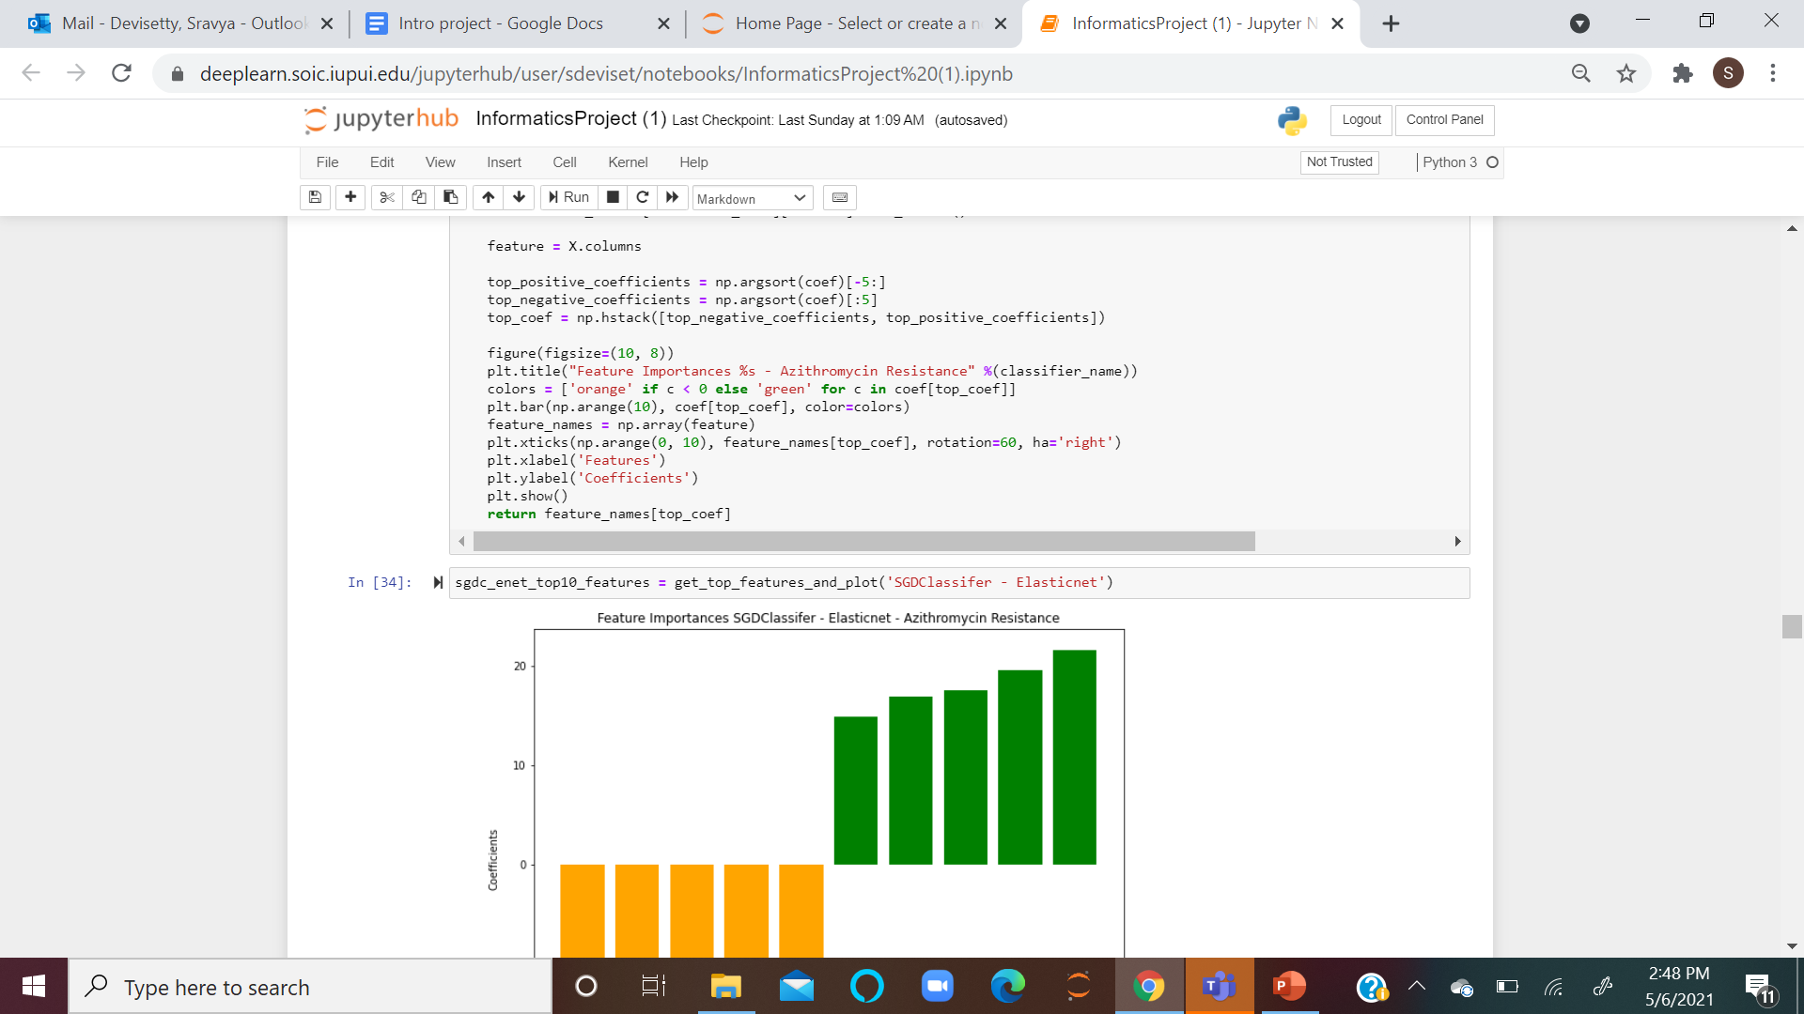

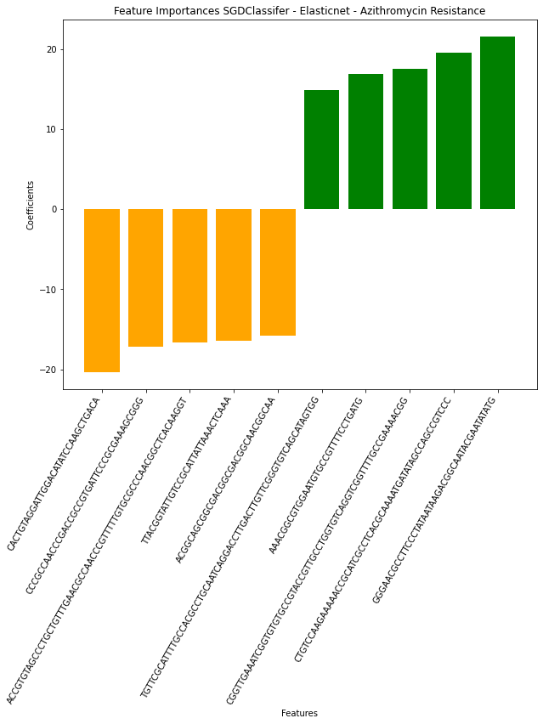

**Fig - 5.6.1: Stochastic Gradient Descent Classifier**

The SDG classifier shows the top 5 positive and top 5 negative genomic regions with the highest effect on Azithromycin Resistance.

* CACTGTAGGATTGGACATATCCAAGCTGACA, ACCGTGTAGCCCTGCTGTTTGAACGCCAACCCGTTTTTGTGCGCCCAACGGCTCACAAGGT, CCCGCCAACCCGACCGCCGTGATTCCCGCGAAAGCGGG, TTACGGTATTGTCCGCATTATTAAACTCAAA, AACATCAGGAAAACGGCACATTCCACGCCGT are the top 5 positive genomic regions and GGAAAGGCGTTTGCGTTGCGAGGAGTTCATCTCG,

AAACGGCGTGGAATGTGCCGTTTTCCTGATG,CGGTTGAAATCGGTGTGTGCCGTACCGTTGCCTGGTGTCAGGTCGGTTTTGCCGAAAACGG,GGGAACGCCTTCCCTATAATAAGACGGCAATACGAATATATG',CTGTCCAAGAAAAACCGCATCGCCTCACGCAAAATGATATAGCCAGCCGTCCC are the top 5 negative genomic regions.

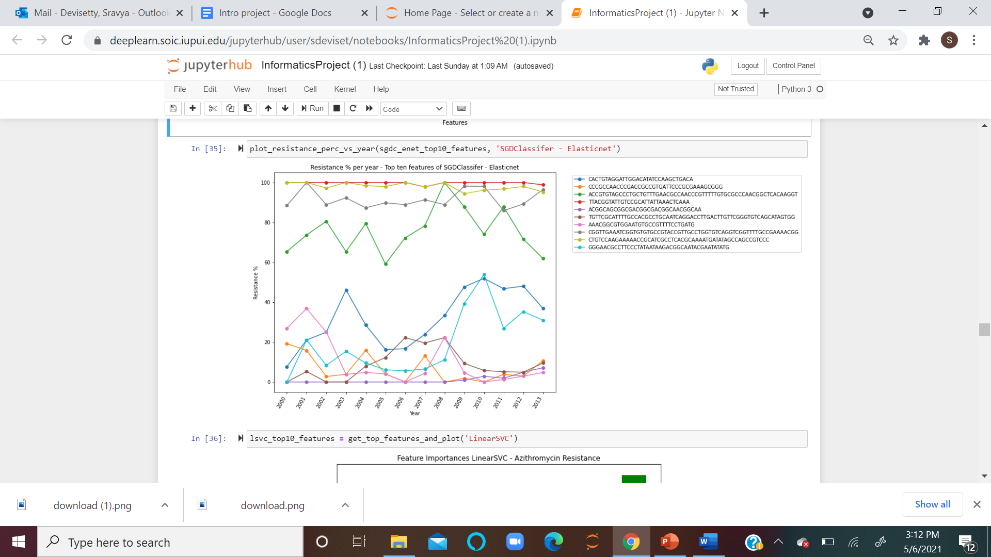

**Fig - 5.6.2: Stochastic Gradient Descent Classifier with top ten features.**

The above plot shows the Azithromycin Resistance % levels for the top 10 genomic regions over the years.

**LINEAR SUPPORT VECTOR CLASSIFIER:**

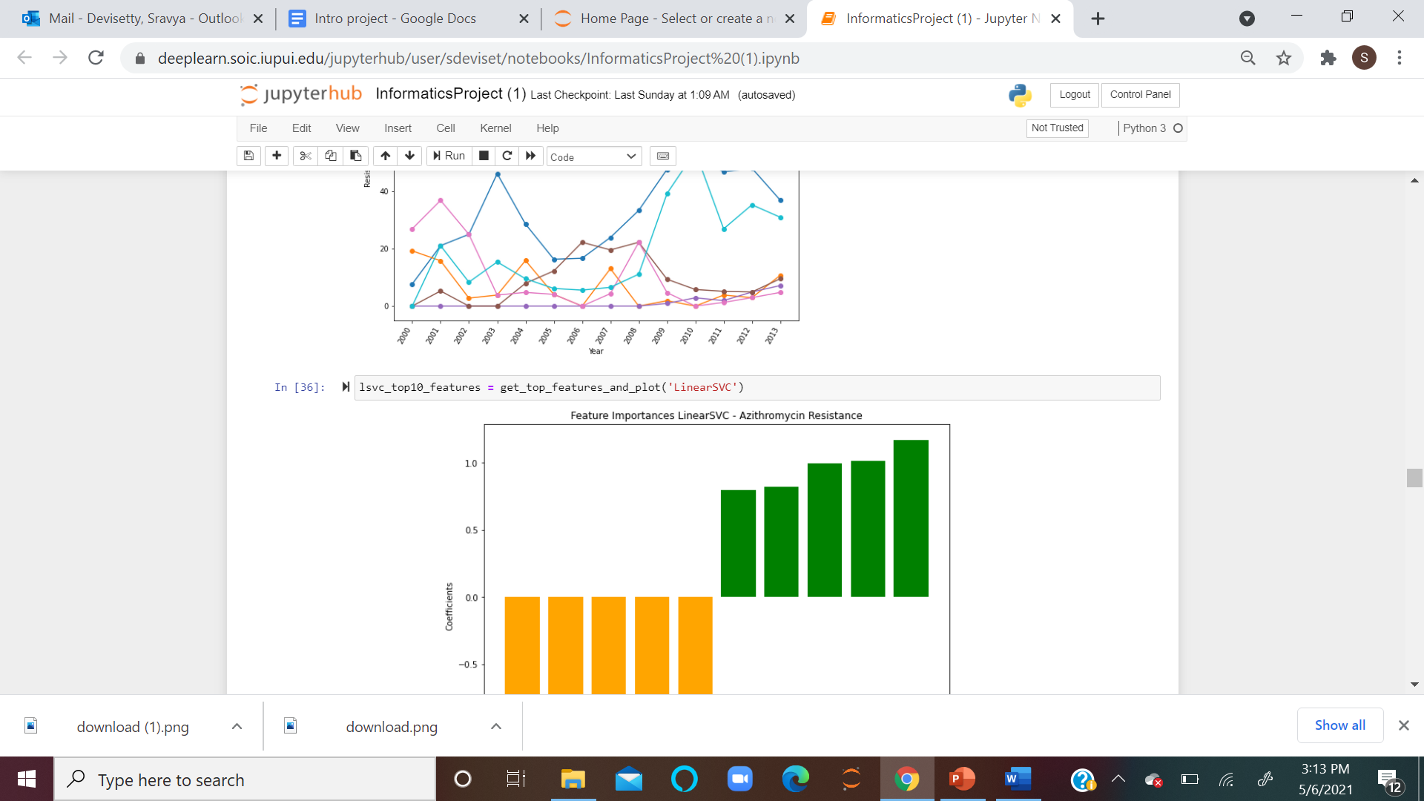

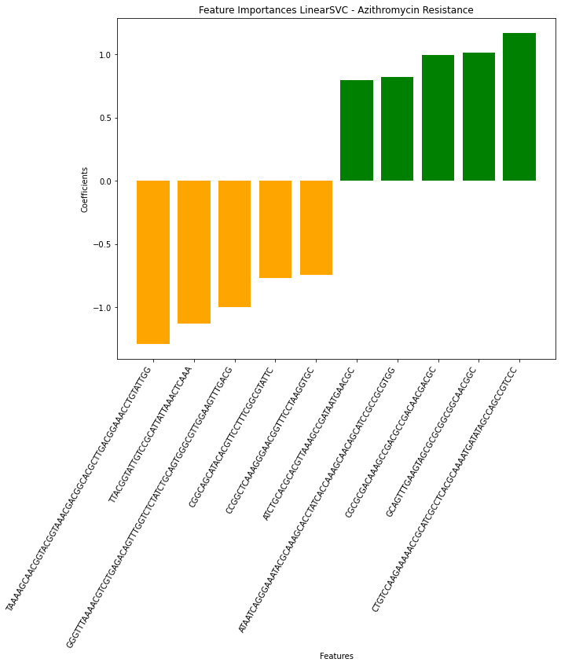

**Fig - 5.7.1: Linear Support Vector Classifier**

The Linear Support Classifier shows the top 5 positive and top 5 negative genomic regions with the highest effect on Azithromycin Resistance.

* TAAAAGCAACGGTACGGTAAACGACGGCACGCTTGACGGAAACCTGTATTGG,TTACGGTATTGTCCGCATTATTAAACTCAAA,GGGTTTAAAACGTCGTGAGACAGTTTGGTCTCTATCTGCAGTGGGCGTTGGAAGTTTGACG,CGGCAGCATACACGTTCCTTTCGGCGTATTC,CCGGCTCAAAGGGAACGGTTTCCTAAGGTGC are the top 5 positive genomic regions and ATCTGCACGCACGTTAAAGCCGATAATGAACGC',ATAATCAGGGAAATACGCAAAGCACCTATCACCAAAGCAACAGCATCCGCCGCGTGG,CGCGCGACAAAGCCGACGCCGACAACGACGC,GCAGTTTGAAGTAGCGCGCGGCGGCAACGGC,CTGTCCAAGAAAAACCGCATCGCCTCACGCAAAATGATATAGCCAGCCGTCCC are the top 5 negative genomic regions .

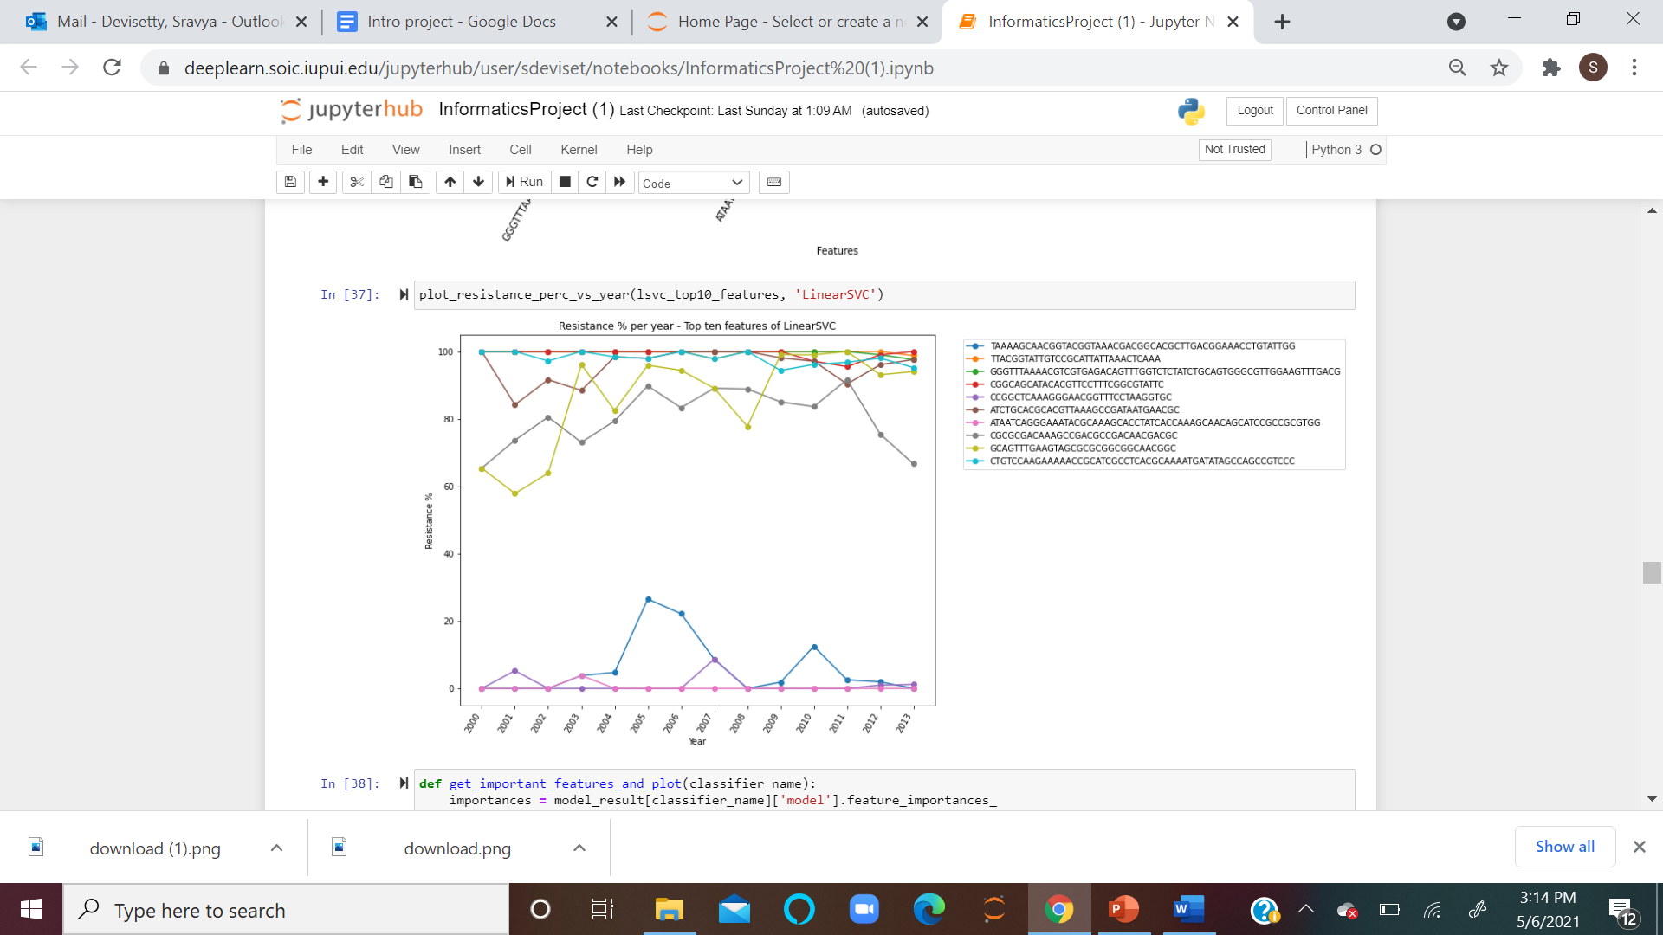

**Fig - 5.7.2: Trends of the top 10 genomic regions over the years.**

The above plot shows the Azithromycin Resistance % levels for the top 10 genomic regions over the years.

**Decision Tree Gini:**

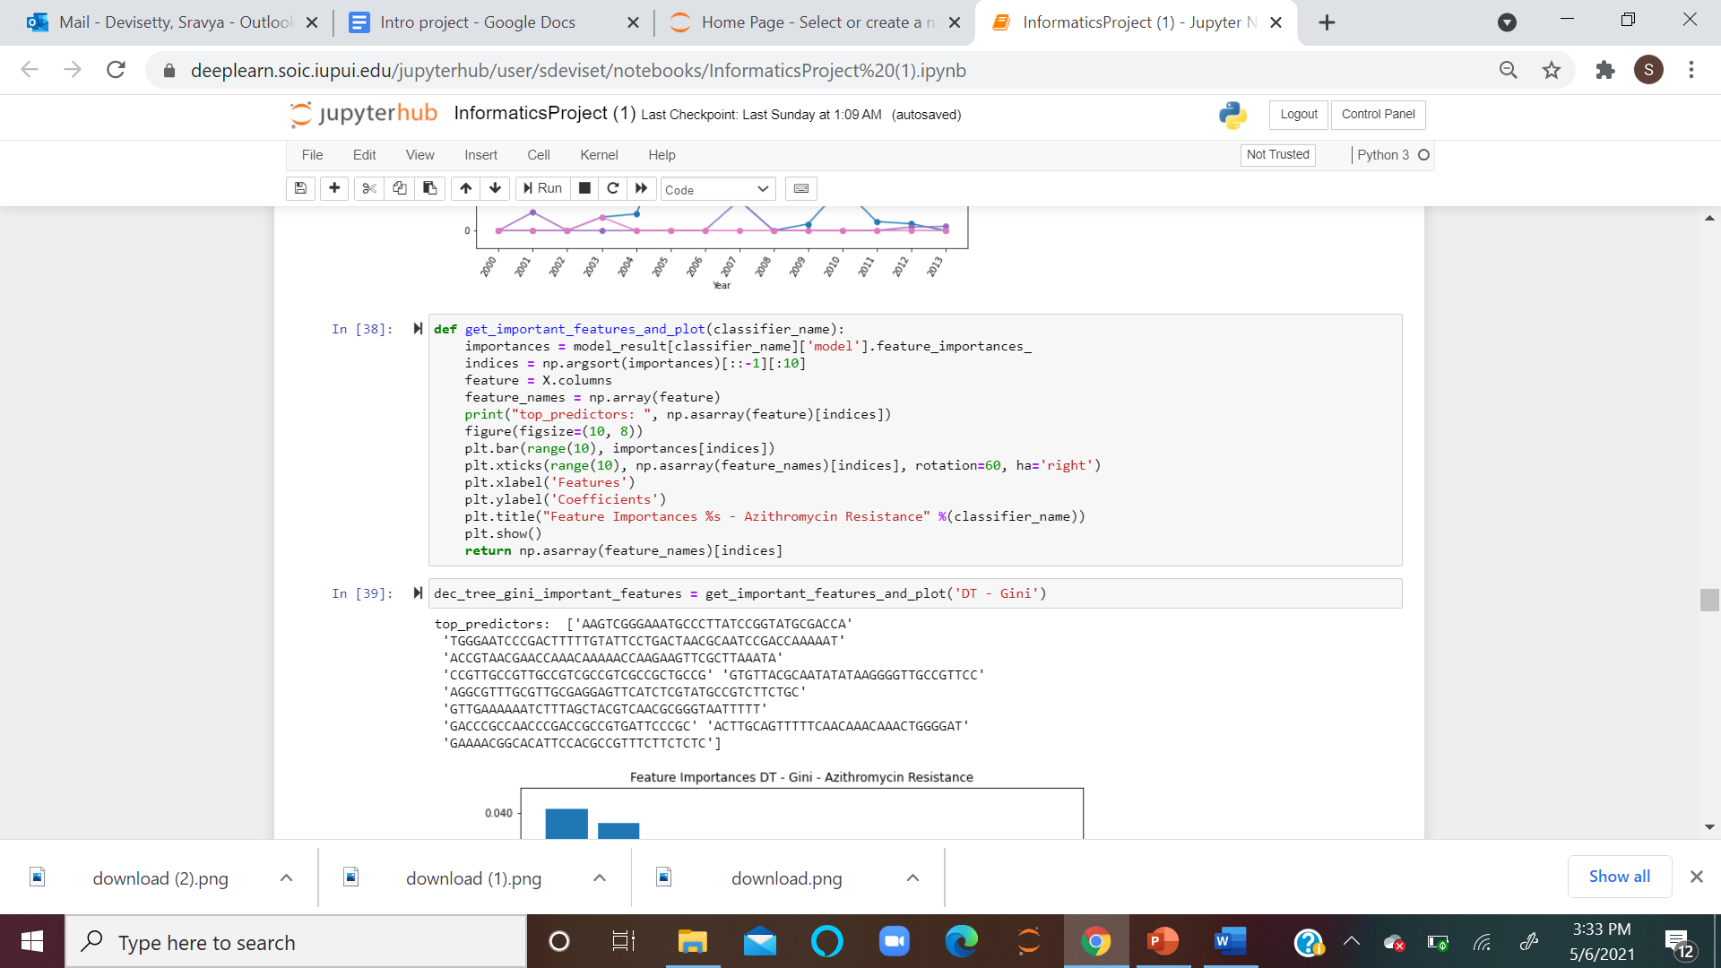

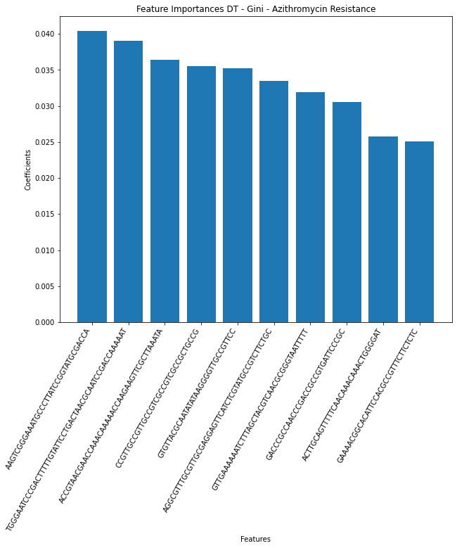 **Fig - 5.8.1: Decision Tree Gini**

The Decision Tree Gini shows the top 10 genomic regions that have the highest effect on Azithromycin levels, and TGGGAATCCCGACTTTTTGTATTCCTGACTAACGCAATCCGACCAAAAAT genomic region has the greatest influence on Azithromycin Resistance among all others as identified by Decision Tree- Gini.

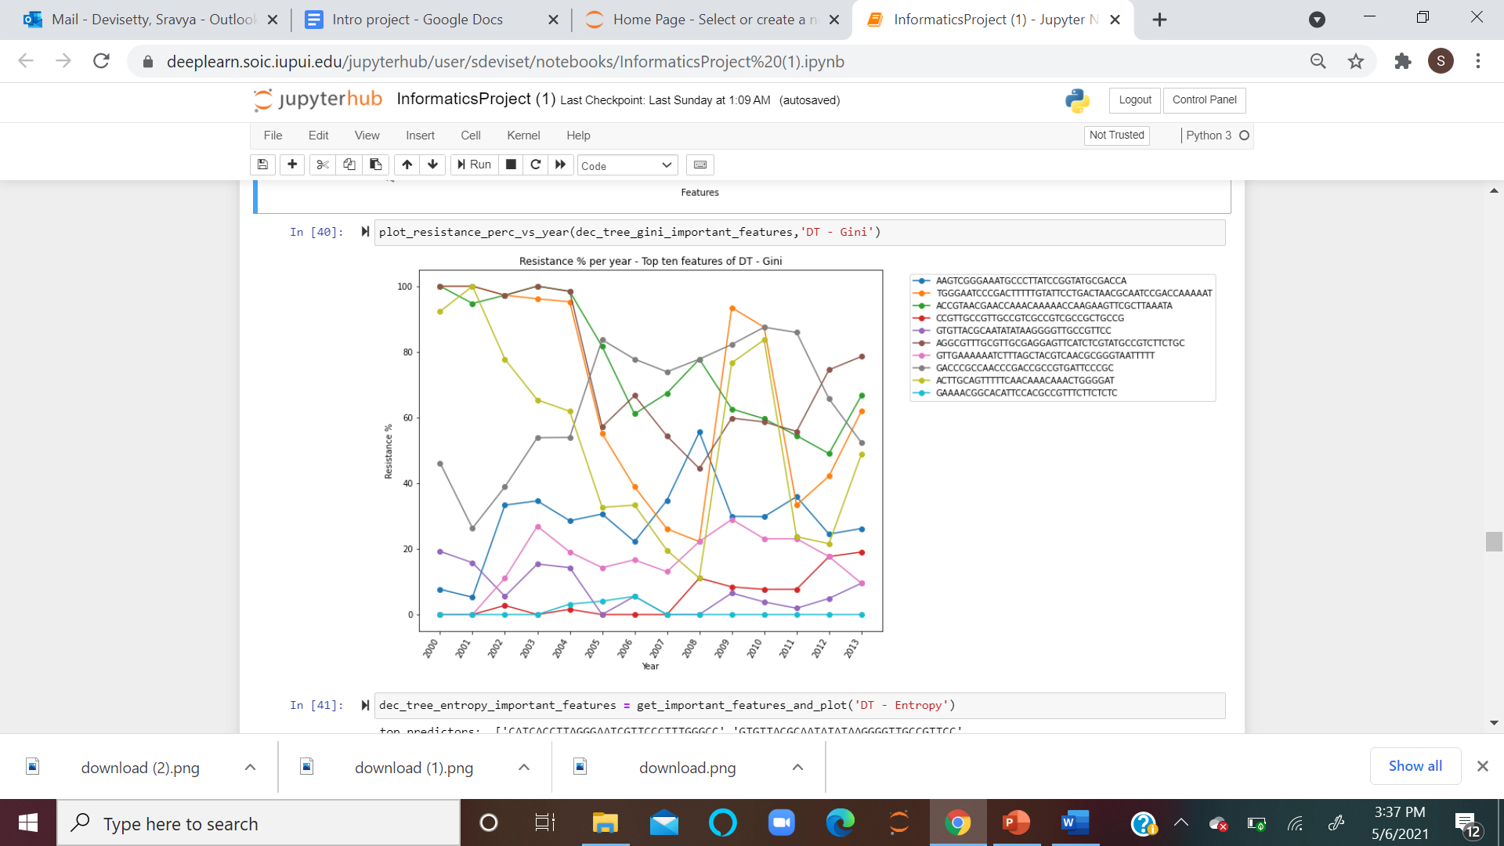

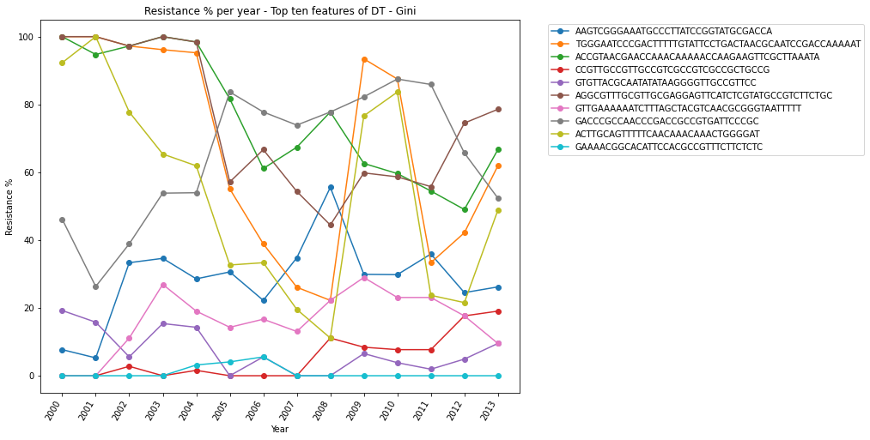 **Fig - 5.8.2: Trends of top 10 genomic regions over the years.**

The above plot shows the trends of Azithromycin Resistance % levels for the top 10 genomic regions over the years.

**DT - ENTROPY:**

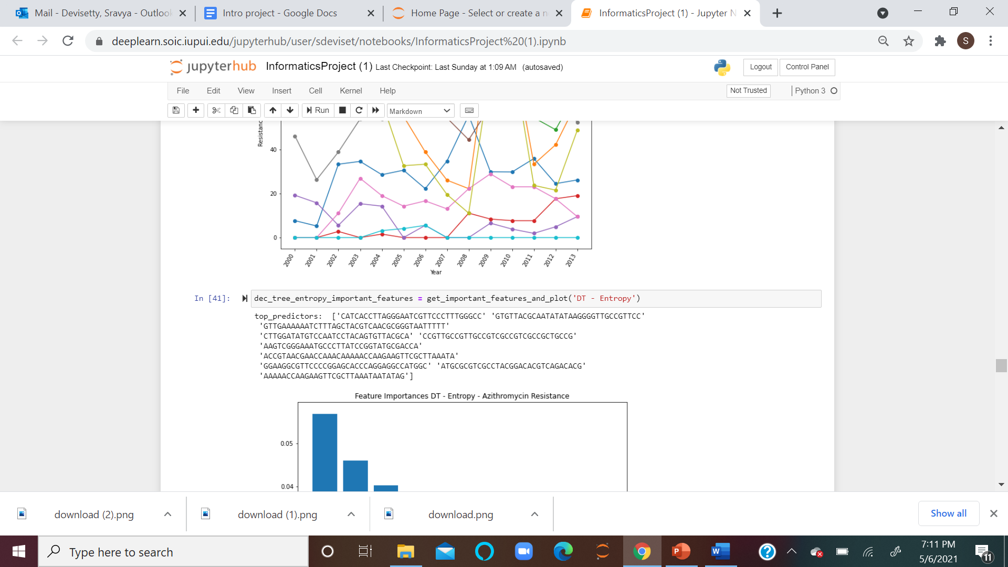

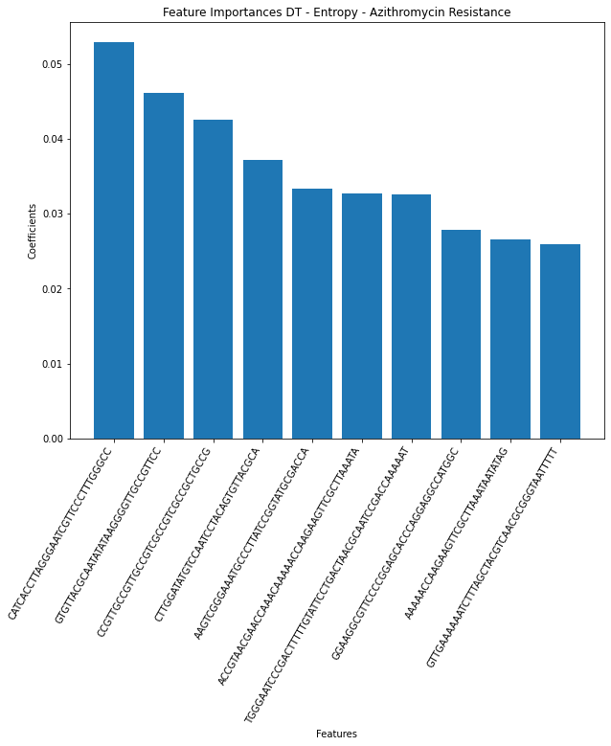

**Fig - 5.9.1: Decision Tree Entropy**

The Decision Tree Entropy shows the top 10 genomic regions that have the highest Azithromycin Resistanceand CATCACCTTAGGGAATCGTTCCCTTTGGGCC has the greatest influence on the Resistance value among all the others as identified by Decision Tree - Entropy.

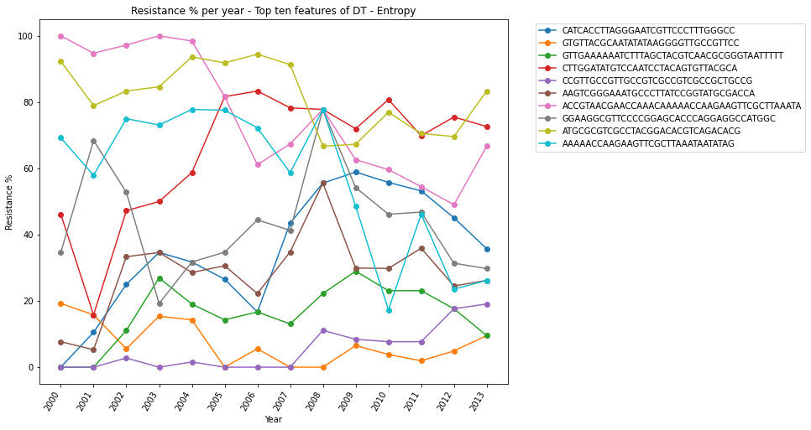

**Fig - 5.9.2: Trends of top 10 genomic regions over the years**

The above plot shows the trends of Azithromycin Resistance % levels for the top 10 genomic regions over the years

The Decision Tree - Entropy has the highest Accuracy percentage, Time taken, and ROC scores; hence we considered the DNA bases analyzed by DT-Entropy for further testing and analysis.

**AdaBoost CLASSIFIER:**

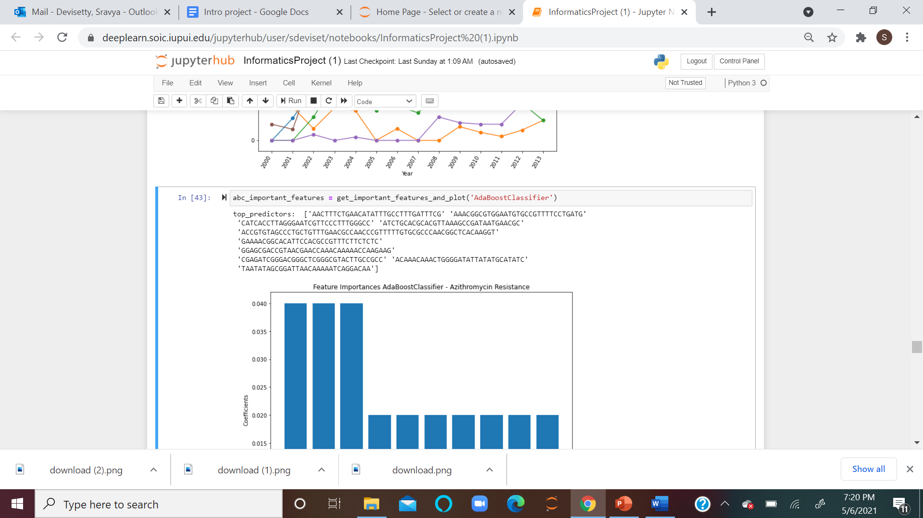

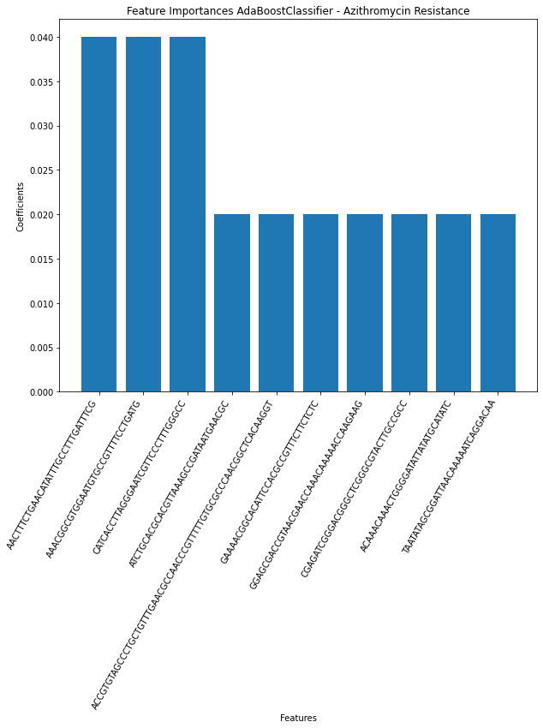

**Fig - 5.10.1: AdaBoost Classifier**

The AdaBoost Classifier shows the top 10 genomic regions with the highest effect on Azithromycin Resistance, and these 3 genomic regions AACTTTCTGAACATATTTGCCTTTGATTTCG, AAACGGCGTGGAATGTGCCGTTTTCCTGATG, CATCACCTTAGGGAATCGTTCCCTTTGGGCC, show the highest values among all the others.

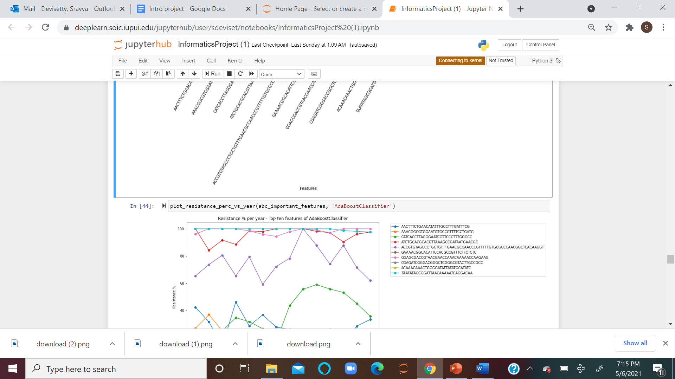

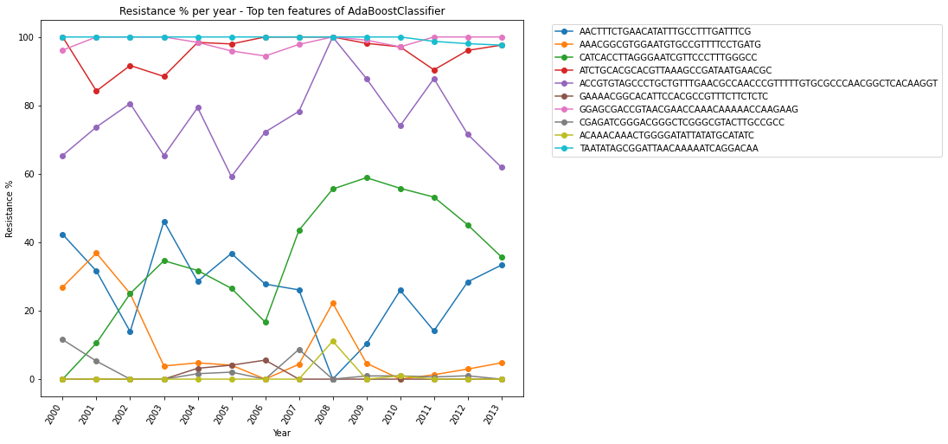

**Fig - 5.10.2: Trends of top 10 genomic regions over the years**

The above plot shows the trends of Azithromycin Resistance % levels for the top 10 genomic regions over the years

**ExtraTreesClassifier - Gini:**

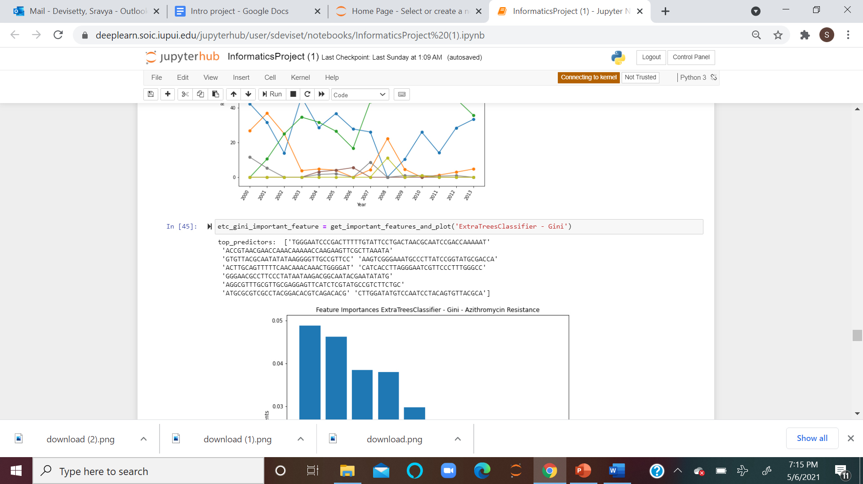

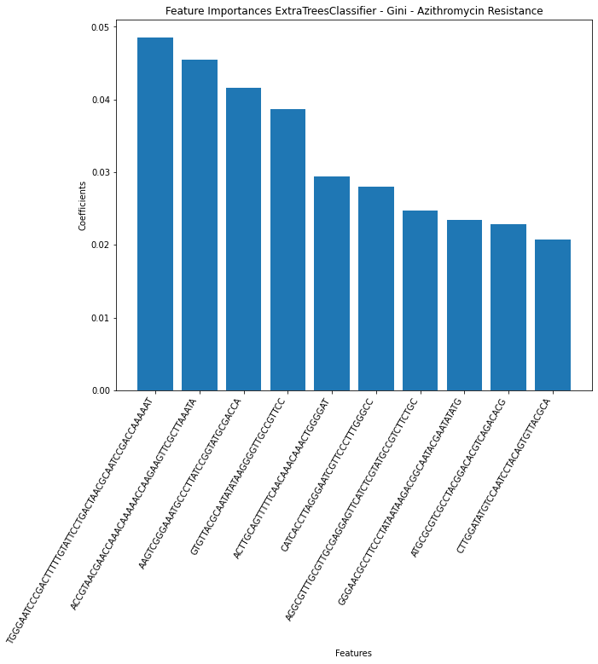

**Fig - 5.11.1: ExtraTreesClassifier - Gini**

The ExtraTreesClassifier - Gini shows the top 10 genomic regions over the years, and TGGGAATCCCGACTTTTTGTATTCCTGACTAACGCAATCCGACCAAAAAT has the strongest influence on the resistance among all others as identified by ExtraTressClassifier - Gini.

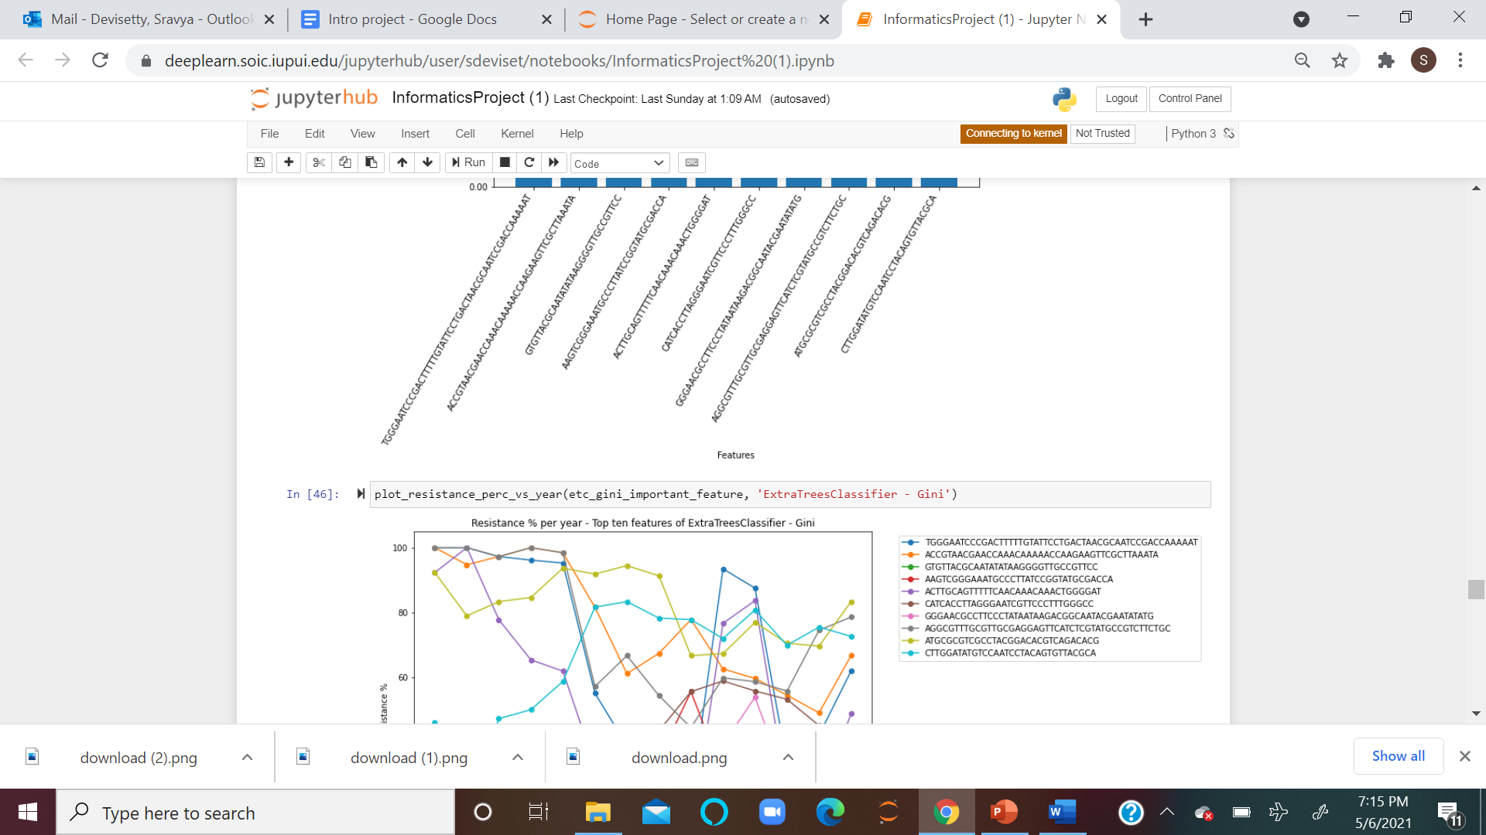

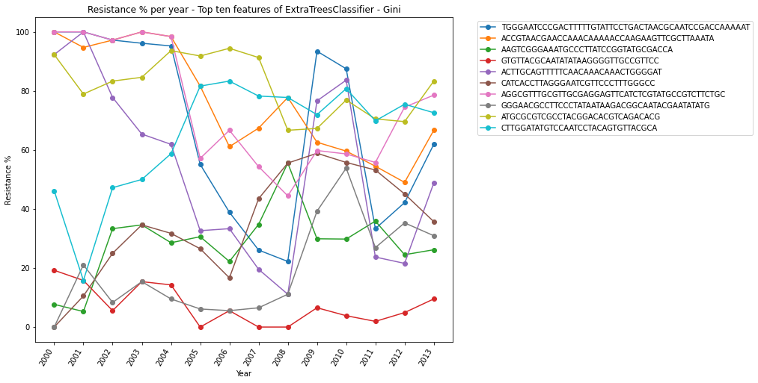**Fig - 5.11.2: Trends of top 10 genomic regions over the years**

The above plot shows the trends of Azithromycin Resistance level for the top 10 genomic regions over the years

**ExtraTressClassifier - Entropy:**

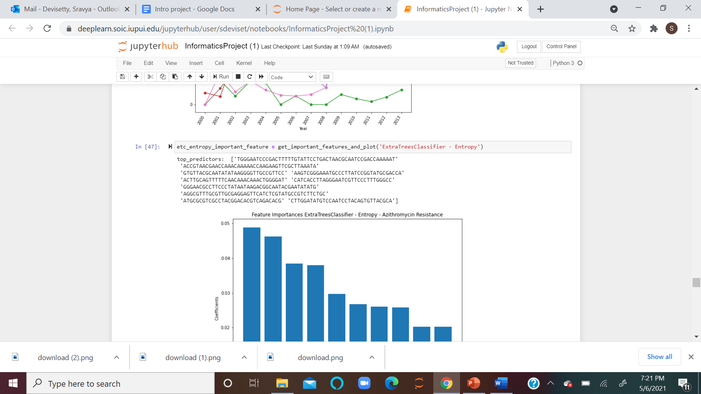

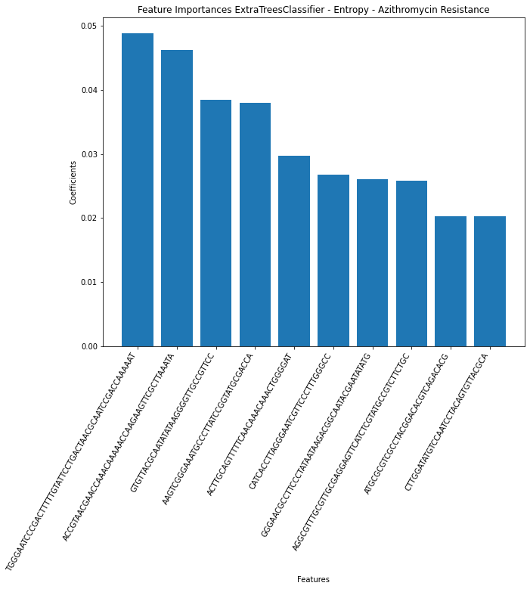

**Fig - 5.12.1: ExtraTreesClassifier - Entropy**

The ExtraTreesClassifier - Entropy shows the top 10 genomic regions that have the highest Azithromycin Resistance, and TGGGAATCCCGACTTTTTGTATTCCTGACTAACGCAATCCGACCAAAAAT has the strongest influence on resistance among all others as identified by ExtraTreesClassifier - Entropy

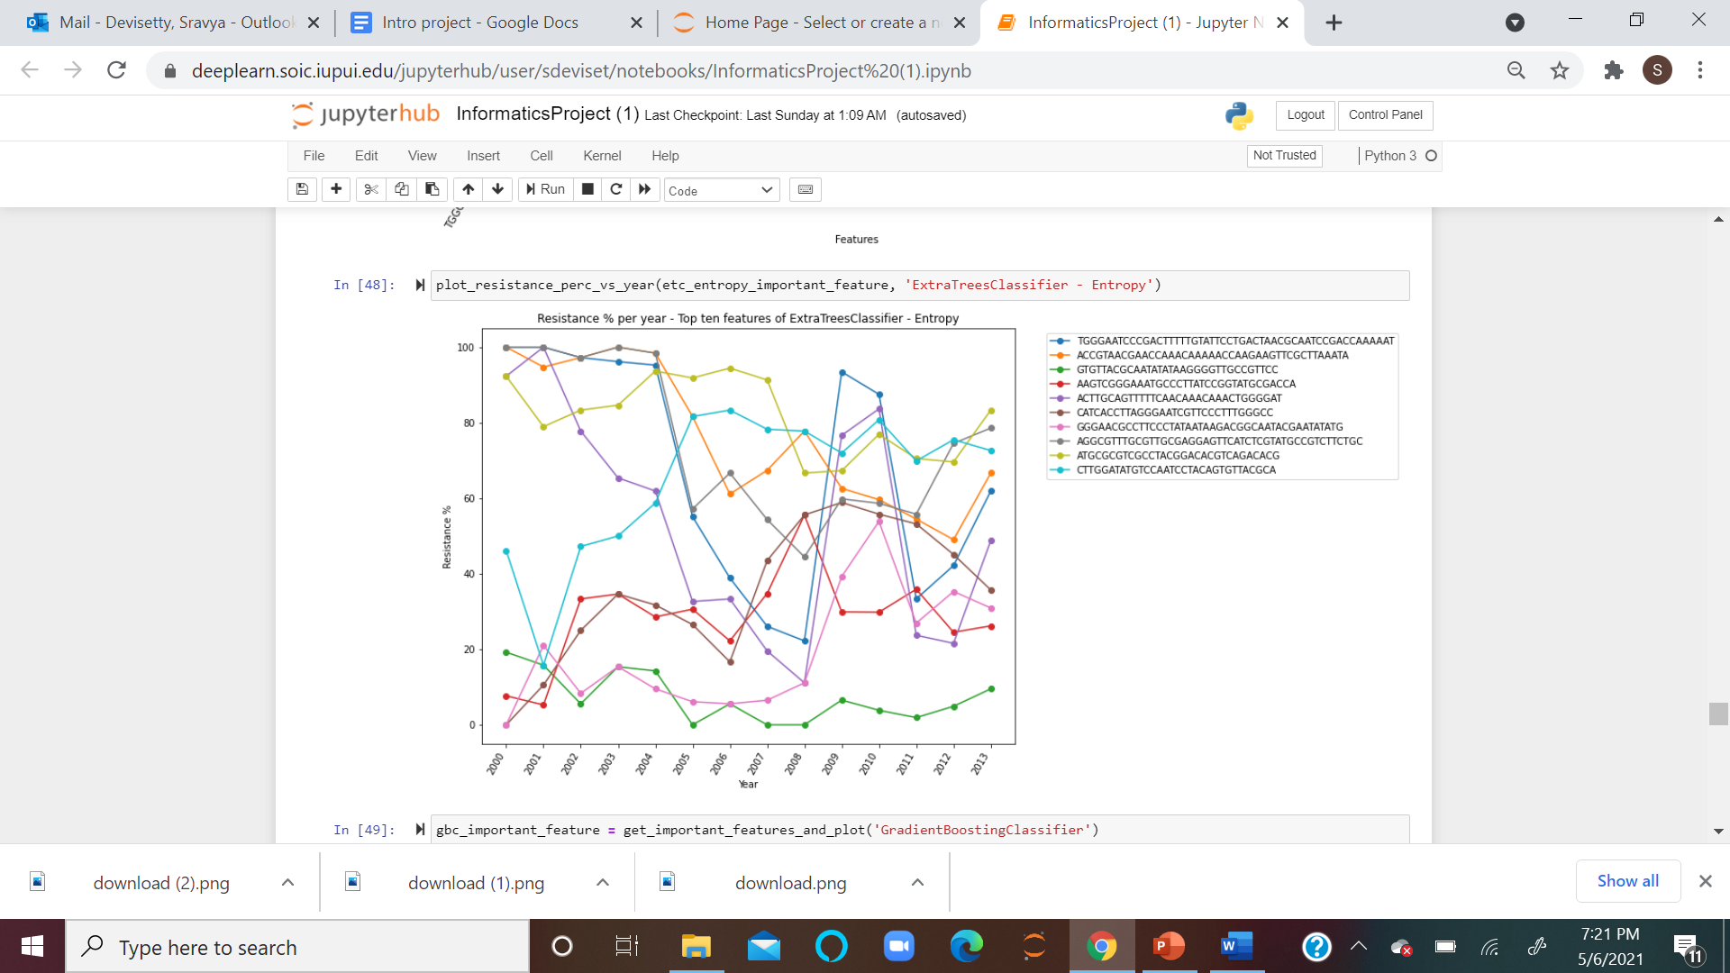

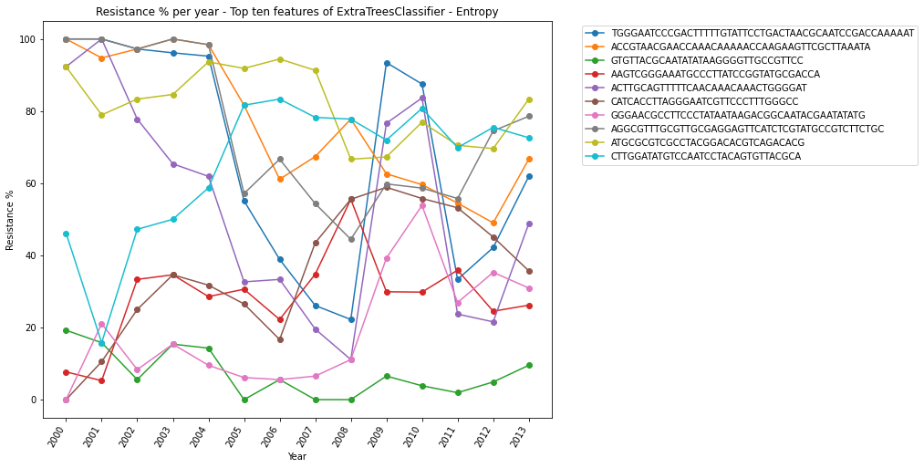

**Fig - 5.12.2: Trends of top 10 genomic regions over the years**

The above plot shows the trend of Azithromycin Resistance % levels over the years

**Gradient Boost Classifier:**

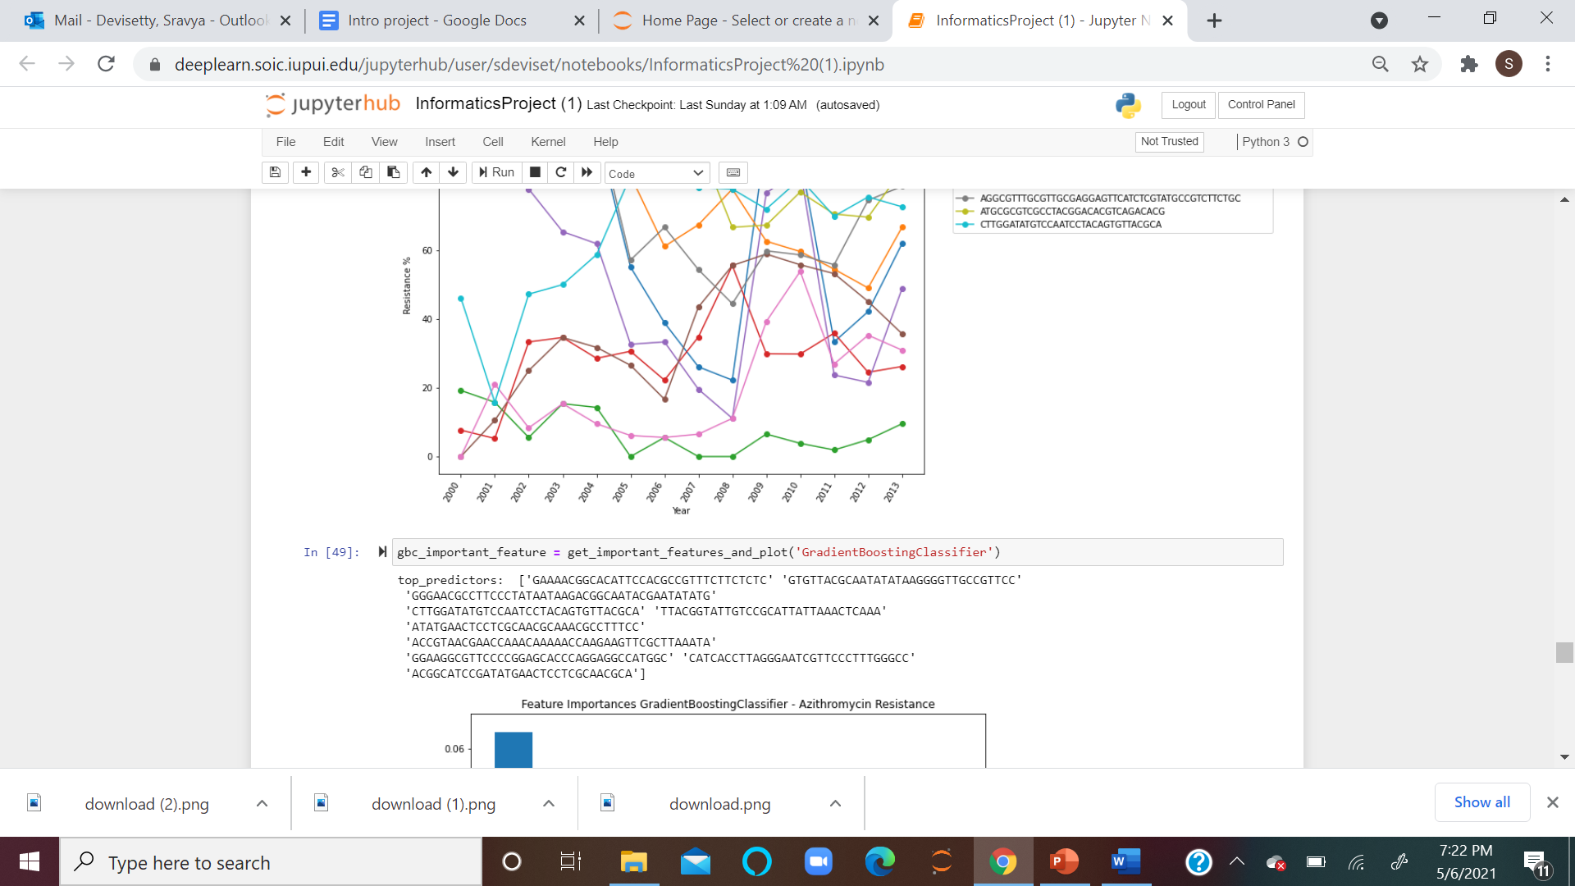

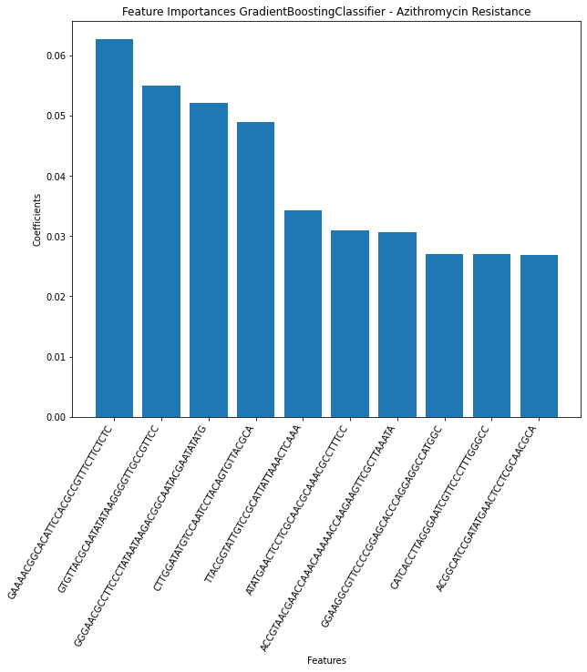 **Fig - 5.13.1: Gradient Boosting Classifier**

The Gradient Boost Classifier shows the top 10 genomic regions that have the highest effect on Azithromycin Resistance, and GAAAACGGCACATTCCACGCCGTTTCTTCTCTC has the highest influence on the resistance among all others as identified by Gradient Boosting Classifier

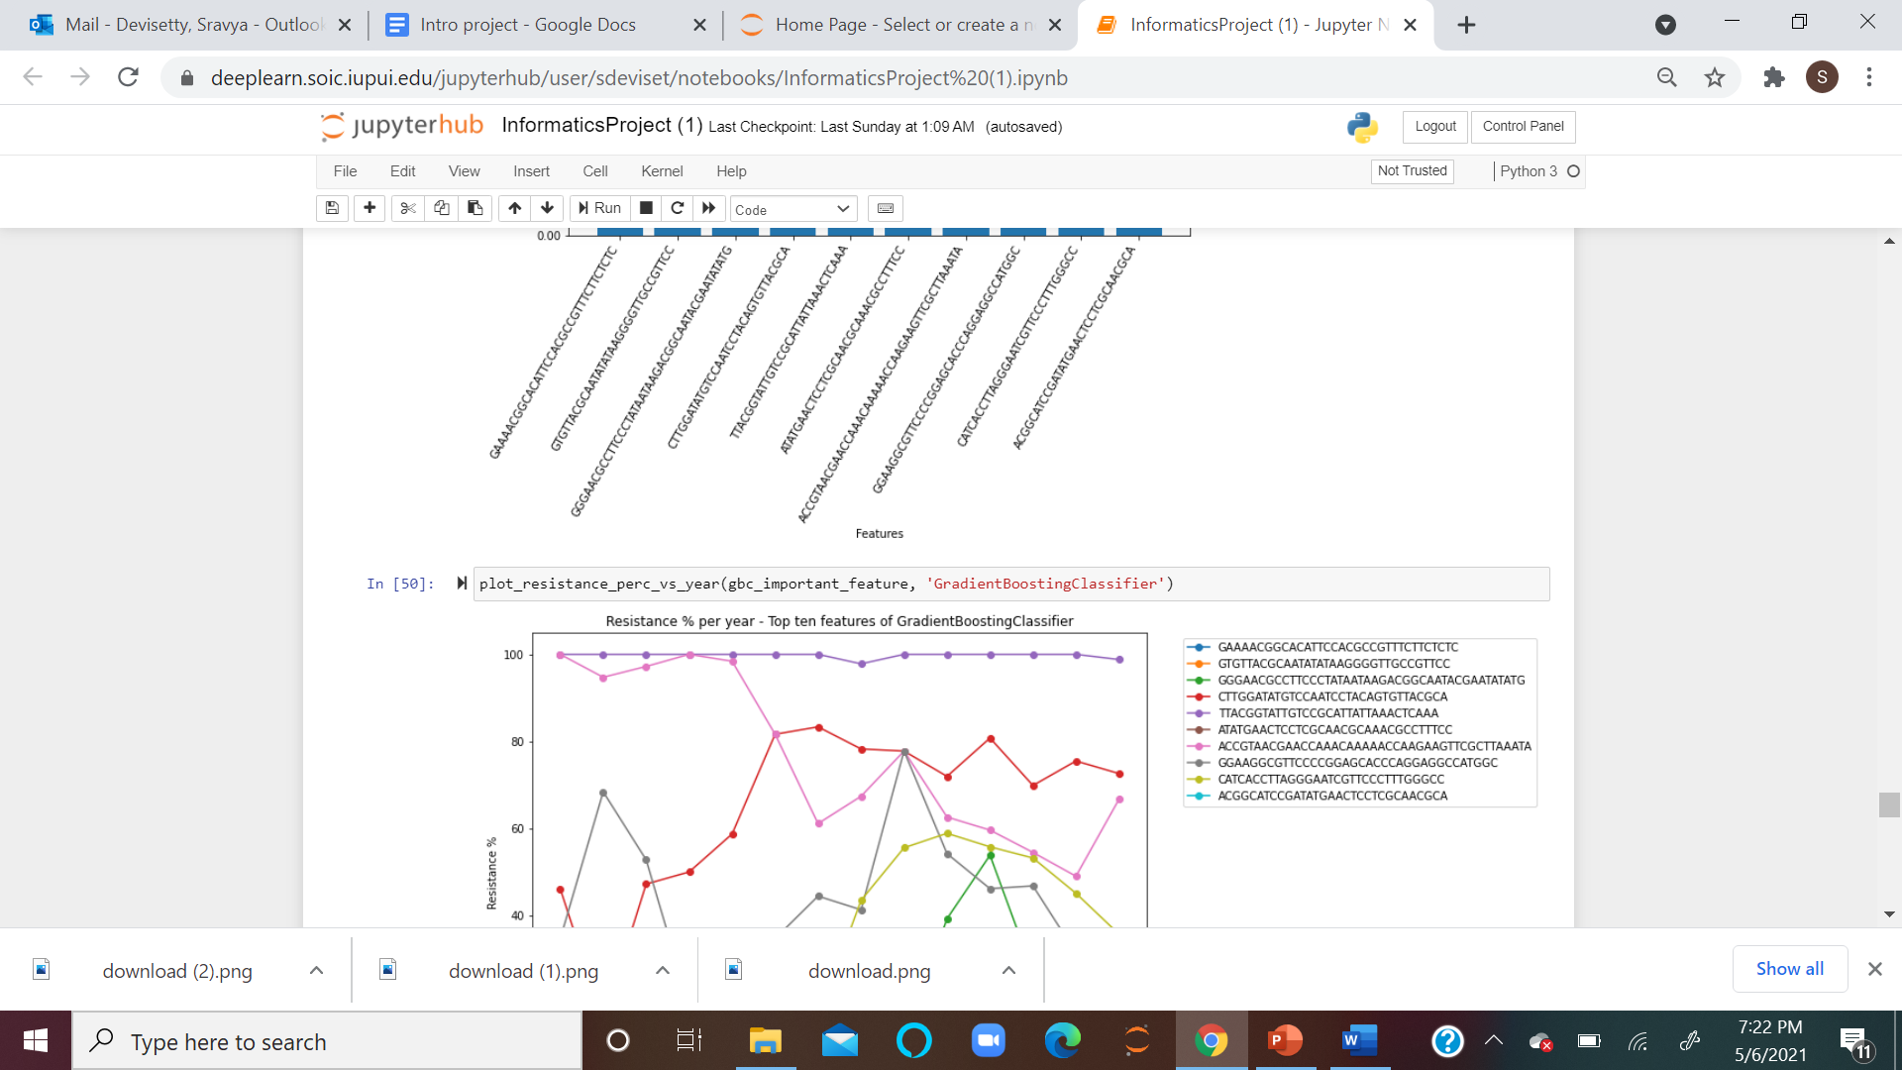

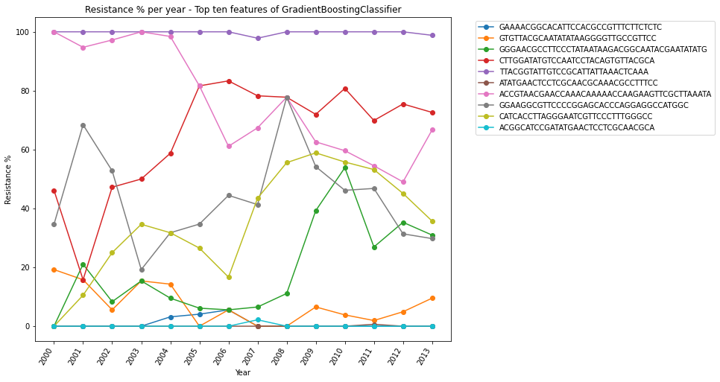

**Fig - 5.13.2: Trends of top 10 genomic regions over the years**

The above plot shows the trends of Azithromycin Resistance % levels for the 10 genomic regions over the years

**RandomForestClassifier - Gini:**

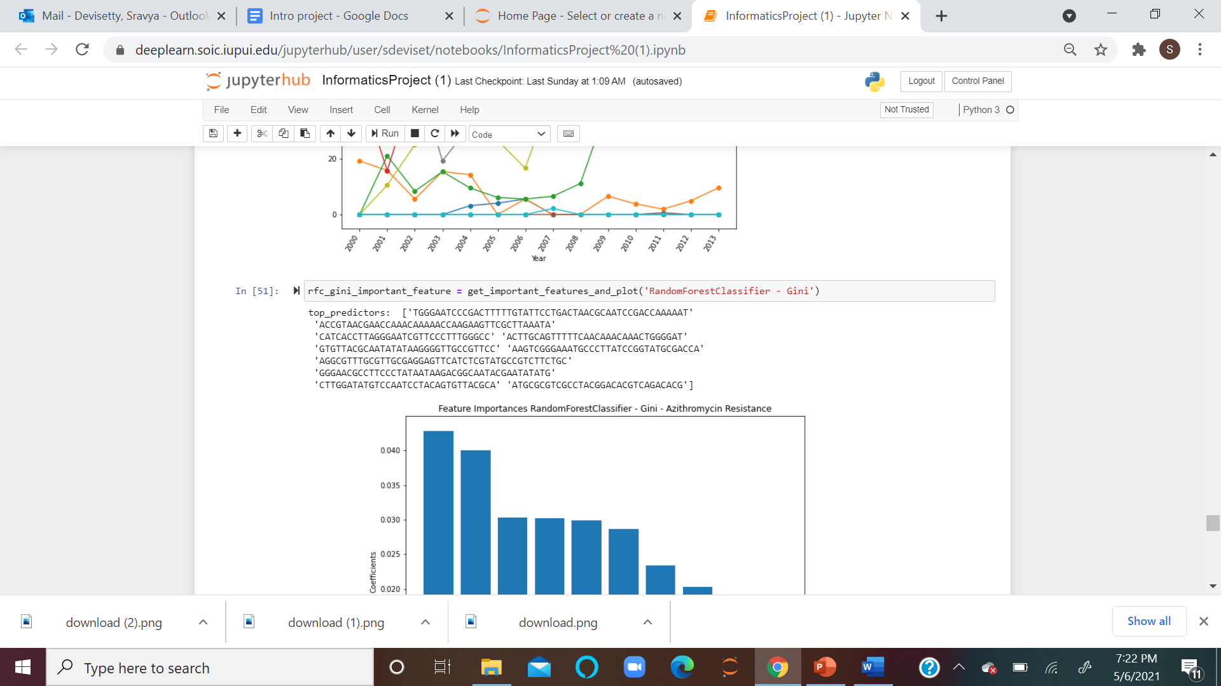

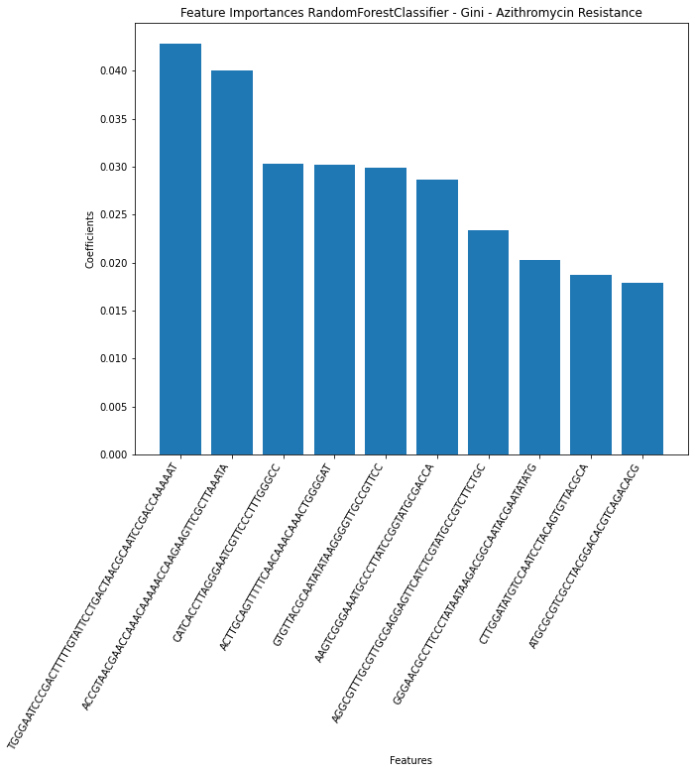

**Fig - 5.14.1: Random Forest Classifier- Gini**

The RandomForestClassifier shows the top 10 genomic regions that have the highest effect on Azithromycin Resistance and TGGGAATCCCGACTTTTTGTATTCCTGACTAACGCAATCCGACCAAAAAT has the highest influence on the resistance among all others as identified by Random Forest Classifier - Gini.

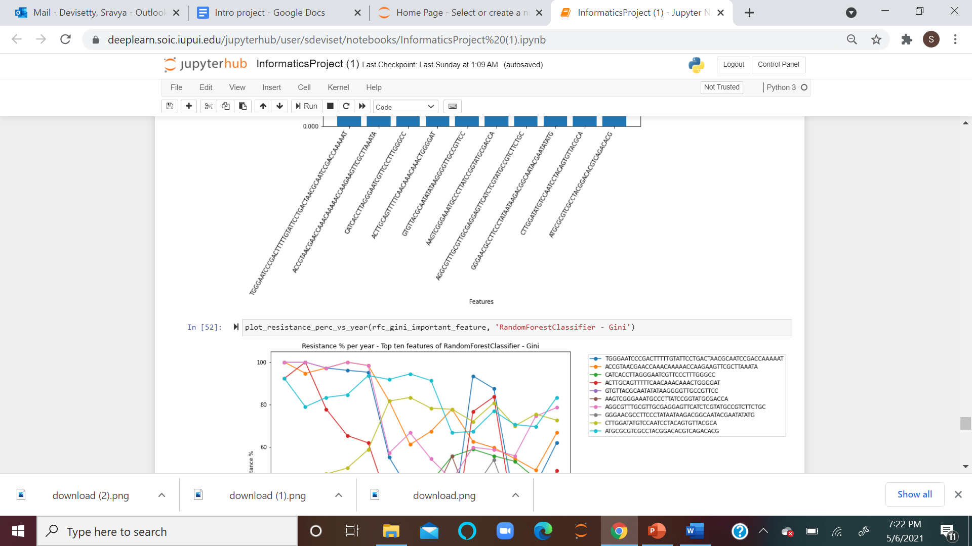

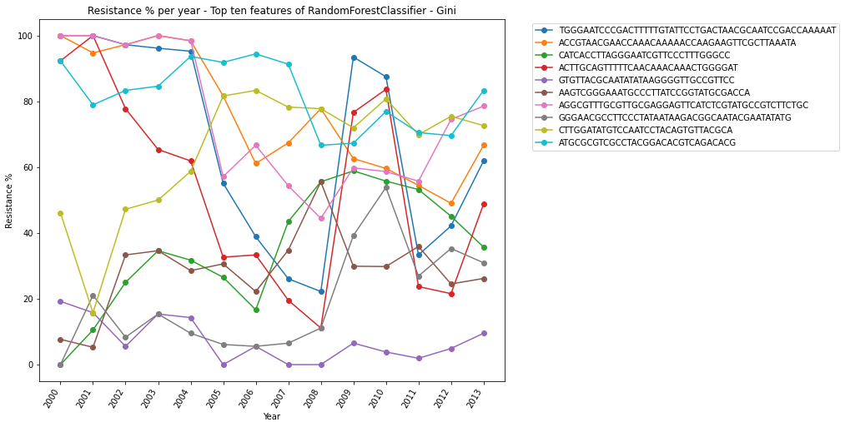

**Fig - 5.14.2: Trends of top 10 genomic regions over the years**

The above plot shows the trends of Azithromycin Resistance % levels for the 10 genomic regions over the years

**RandomForest Classifier - Entropy:**

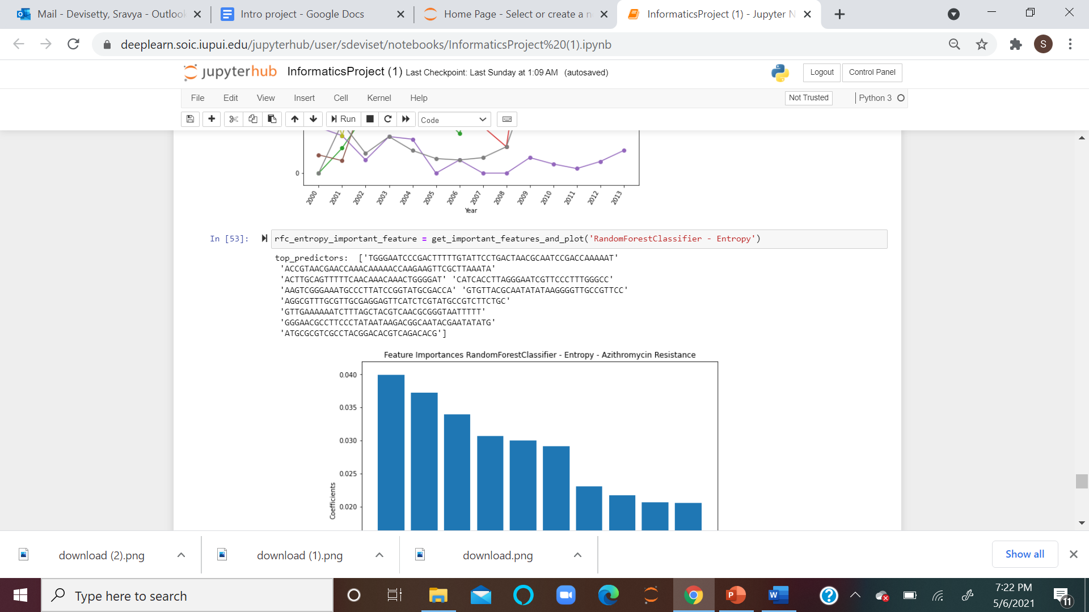

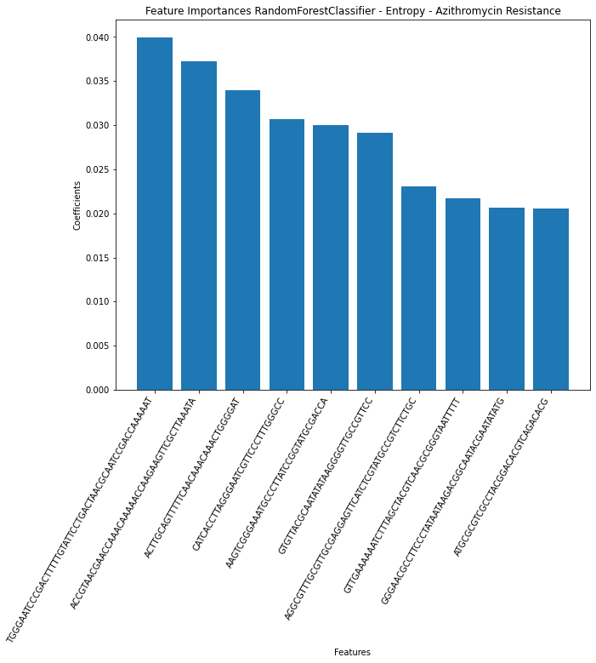

**Fig - 5.15.1: Random Forest Classifier- Entropy**

The RandomForestClassifier - Entropy shows the top 10 genomic regions that have the highest effect on Azithromycin levels, and TGGGAATCCCGACTTTTTGTATTCCTGACTAACGCAATCCGACCAAAAAT has the highest influence on the resistance among all others as identified by Random Forest Classifier - Entropy.

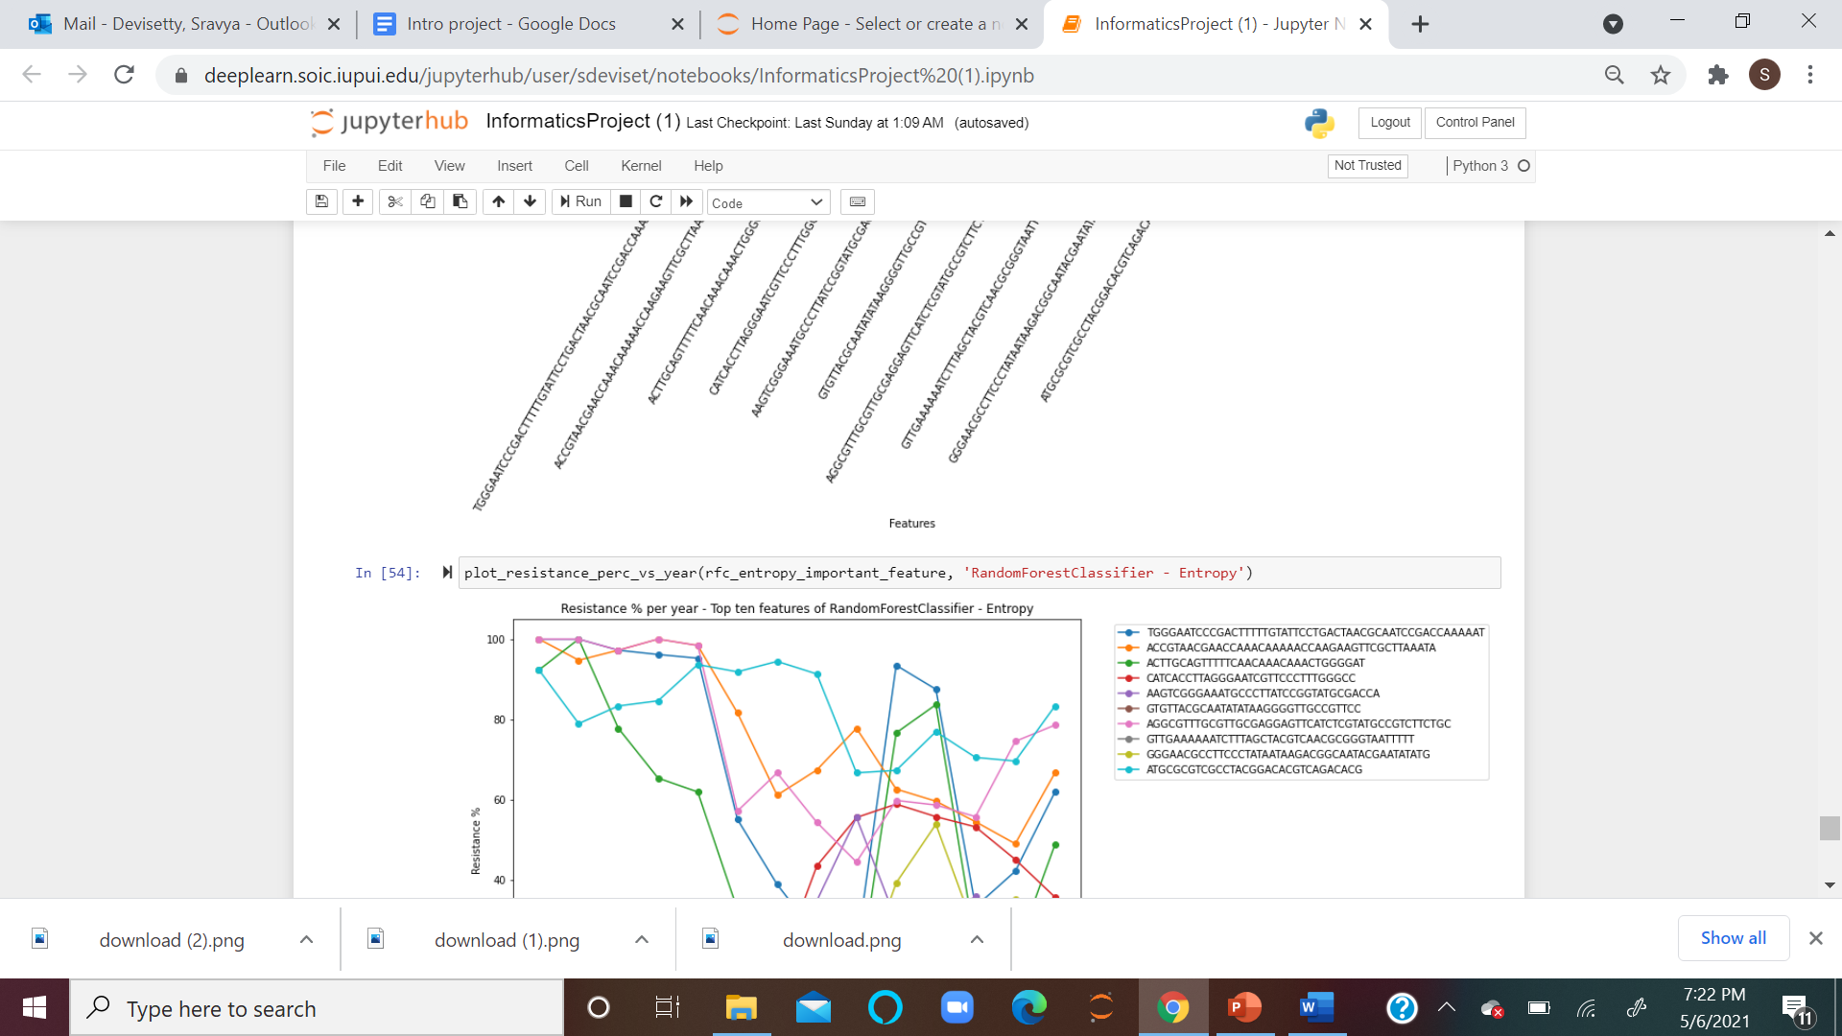

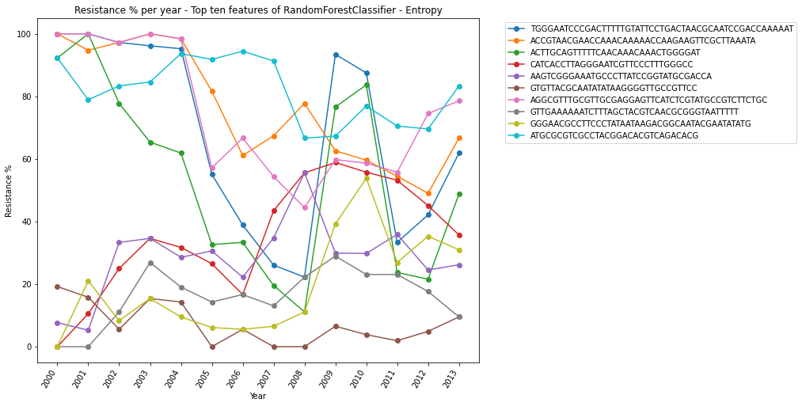

**Fig - 5.15.2: Trends of top 10 genomic regions over the years**

The above plot shows the trends of Azithromycin Resistance % levels for the top 10 genomic regions over the years

**Linear Regression:**

Linear Regression is an analysis tool that helps to predict the future trend of the study. We used this tool to perform various comparisons and predicted the results.

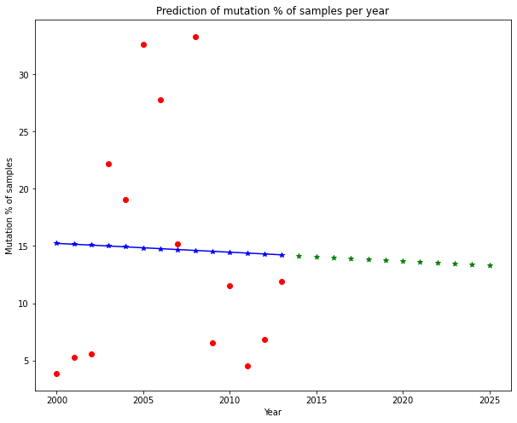

**Fig 5.16.1: Prediction of mutation % of samples per year**

Fig 5.16.1 shows the future prediction of Mutations using the samples given and plotting them according to the year wise. This helps to predict the resistance of azithromycin.

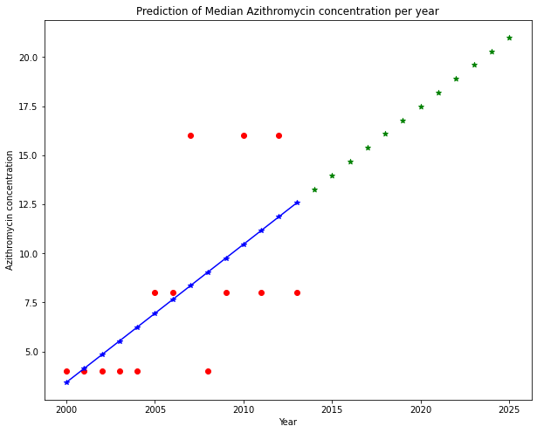

**Fig 5.16.2: Prediction of Median Azithromycin concentration per year**

Fig 5.16.2 depicts the median Azithromycin concentration per year till 2025, and it will reach more than 20 micrograms per milliliter by the year 2025.

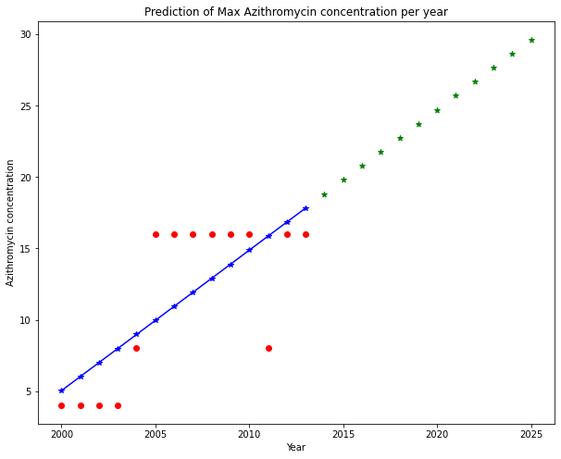

**Fig 5.16.3: Prediction of Max Azithromycin concentration per year**

Fig 5.16.3 shows the maximum azithromycin consumption according to the year, and it will reach more than 30 micrograms per milliliter by the year 2025

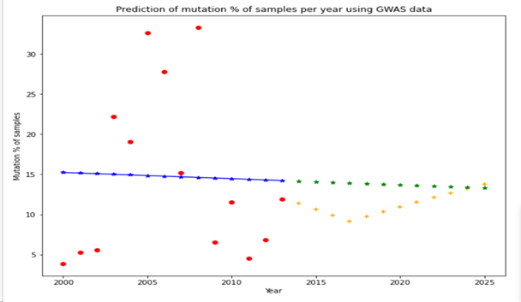

**Fig 5.16.4: Prediction of Mutation percent of samples per year using GWAS data**

Fig 5.16.4 helps to predict the mutation percent of samples according to the year involving the GWAS data. The trend shows the decline in the percent, and there will be no hike in the resistance by the year 2025.

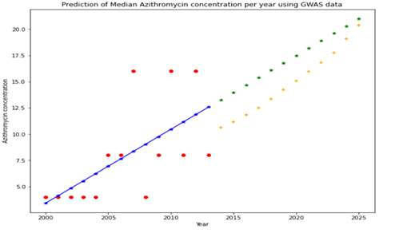

**Fig 5.16.5**: **Prediction of Median Azithromycin concentration per year using GWAS data**

Fig 5.16.5 predicts the median azithromycin concentration per year using GWAS data, and the trend shows there will be a stable growth in azithromycin consumption.

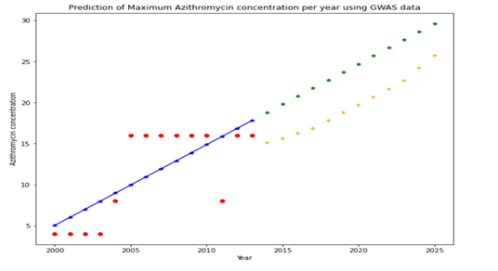

**Fig 5.16.6: Prediction of Maximum Azithromycin concentration per year using GWAS data**

Fig 5.16.6 predicts the maximum rate of azithromycin will be consumed by 2025. The GWAS data is involved in predicting the trend according to the Genes unities of Neisseria Gonorrhoeae. The trend says that it will increase to 30 micrograms per milliliter.

**6. Data Visualization**

Visualization is an important part of all data analysis techniques, including computational genomics. Again, you can use core visualization techniques using python libraries for CSV and genomics-specific ones with the help of specific packages.

Mostly used plots are histograms, scatter plots, bar plots, box plots, heatmaps.

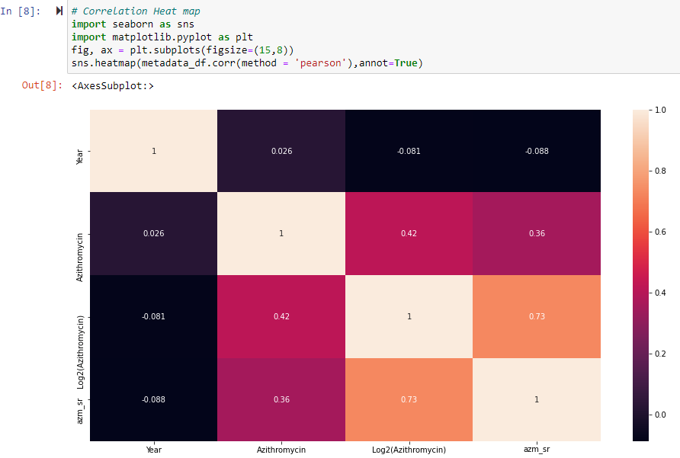

The above heatmap is plotted for the attributes of cleaned metadata, and the obtained plot results show a slight positive correlation between Azithromycin and azm_sr.

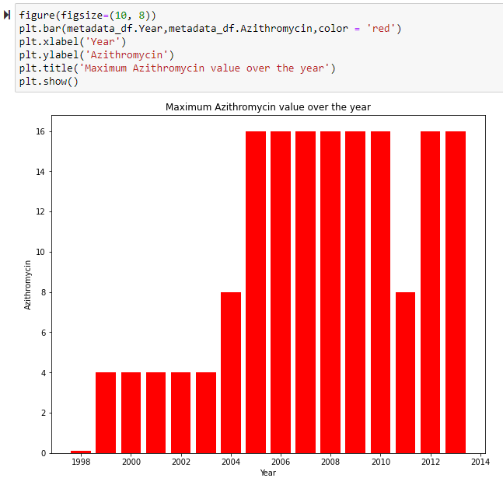

The above bar chart is drawn between Azithromycin and years for the maximum Azithromycin levels over the years. From the plot, it is clear that there is an increase in Azithromycin consumption from the year 1998 to 2005 and was maintained constant till 2010 but in the year 2011, there is a sudden decrease in the Azithromycin levels which again showed an increase in Azithromycin consumption for the next 2 years.

**6.1 Tableau Data Visualization – Count per year**

We have also used tableau visualization using version 2020.4. We used tableau because it provides a fast and easy visualization method to analyze azithromycin MIC based on year, count average, and other measurements as required. Accordingly, we have imported the cleaned metadata into tableau and created the following visualizations.

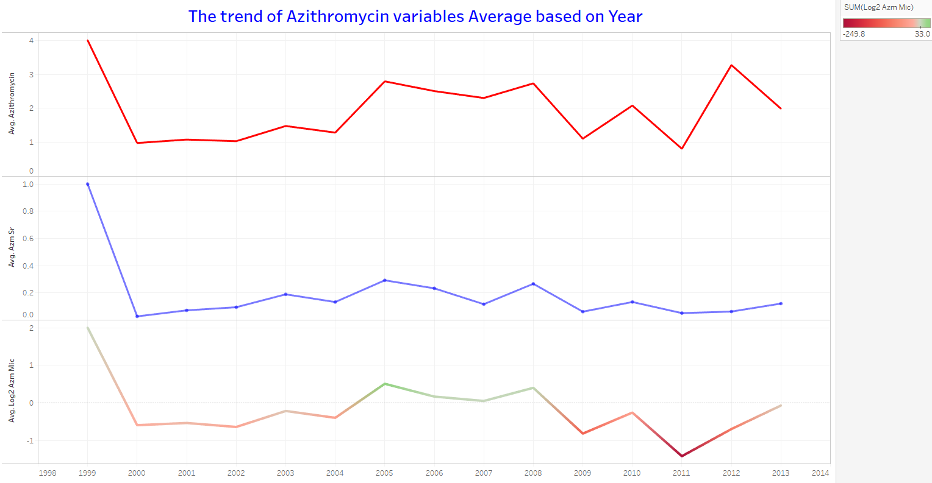

Fig: trend of average variables over the years

The above line graph represents the three trends of the Azithromycin data, they are Azithromycin consumption rate, Resistance, and the log value of Azithromycin consumption. These trends can be helpful to predict further analysis.

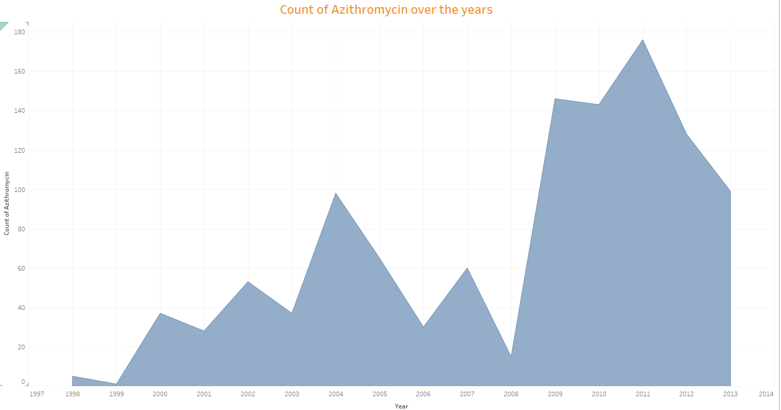

**Fig: Count of Azithromycin over the years**

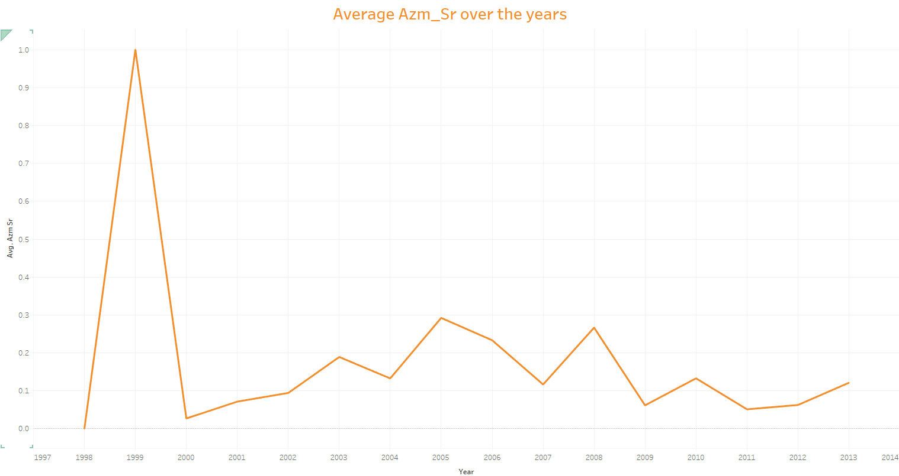

**Fig: Average Azm_sr over the years**

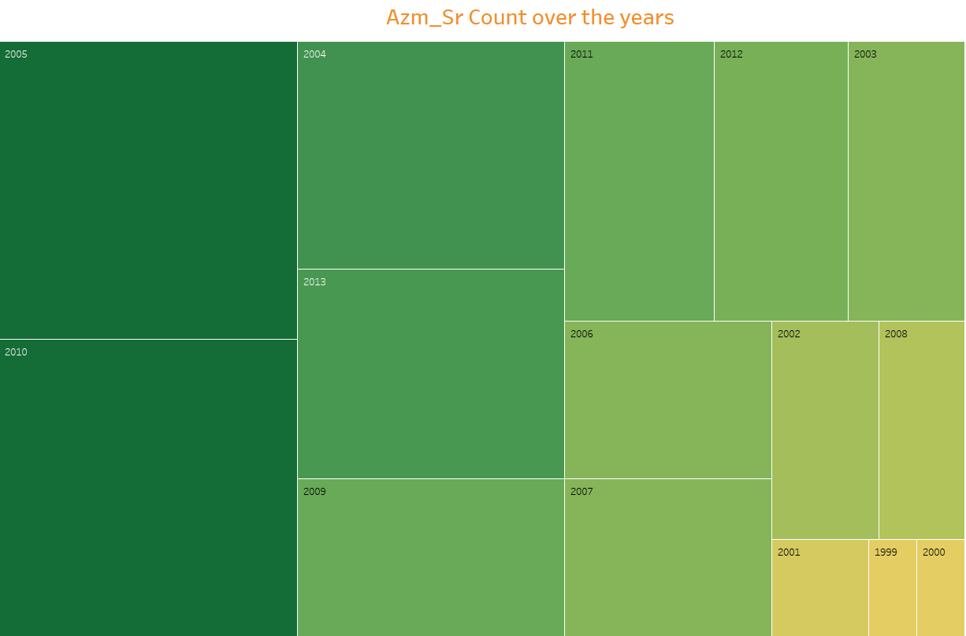

**Fig: Azm_sr count over the years**

**7. Summary of Findings:**

We developed a hypothesis to test in our initial project proposal. By 2025, we predict an increase in the rate of Azithromycin consumption for the reasons listed:

1. In the future, there will be an increase in the number of different bacterial infections.

2. Diseases of the pulmonary and other systems are becoming more prevalent.

3. A huge increase in the number of variant bacterial pathogens attributed to COVID - 19

We demonstrated that the hypothesis testing process is validated by data analysis, statistical test, and visualizability, based on the research methods and techniques we often used to evaluate our hypothesis.

**7.1 Research Question One Finding:**

Our first research question was “ To identify various unitigs responsible for the bacterium *N.gonorrhoeae* ” and below are the findings:

1. We identified that five genes i.e. “ NGMG_00872, EGK74_13440, N776_04030, A2X74_05240, BHV70_00400” were responsible for showing high resistance among all other gene sequences.

**7.2 Research Question Two Findings:**

Our second research question was “ To predict the trends of Azithromycin consumption by the year 2025” and below are the findings:

1. There was a slight positive correlation between Azithromycin and azm_sr (Azithromycin resistance
2. There was an increase in the Azithromycin levels over the years till 2025.
3. There was a decrease in Azithromycin Resistance over the years till 2025.
4. Eventually with the decrease in mutations and increase in the concentration of Azithromycin levels, we predicted that there would be an increase in Azithromycin consumption by 2025.

**8. Limitations:**

* During the initiation process, we faced difficulties to differentiate between Azithromycin and Azithromycin Minimum Inhibitory Concentration(Azithromycin).
* There was no clarity regarding the columns in the GWAS data that related to the azithromycin, and we searched for so many resources to avoid confusion, after all the efforts, we contacted the owner of the dataset, she guided us through the right columns.
* Limited related columns in metadata as most of the columns are insignificant for our analysis.

**9. Future direction:**

This study can be continued for future work, with other factors and variables related to Azithromycin with the present study. We believe that additional datasets and this study would help predict different Azithromycin trends and analyses.

**References**

*Antimicrobial resistance following mass azithromycin ...* <https://www.thelancet.com/journals/laninf/article/PIIS1473-3099(18)30444-4/fulltext>

Bignell, C., & Garley, J. (2010). Azithromycin in the treatment of infection with Neisseria gonorrhoeae. *Sexually Transmitted Infections*, *86*(6), 422–426.<https://doi.org/10.1136/sti.2010.044586>

Gyselinck, I., Janssens, W., Verhamme, P., &amp; Vos, R. (2021). Rationale for Azithromycin in COVID-19: an overview of existing evidence. BMJ Open Respiratory Research, 8(1). https://doi.org/10.1136/bmjresp-2020-000806

U.S. National Library of Medicine. *Azithromycin: MedlinePlus Drug Information*.MedlinePlus.<https://medlineplus.gov/druginfo/meds/a697037.html>.

MarketWatch. (2021, February 3). *Azithromycin Market 2021 Trends Evaluation, Latest Innovation, Consumer-Requirement, Key Players, Consumption Status, Industry Dynamics, Covid-19 Impact and Forecast till 2025*. MarketWatch. <https://www.marketwatch.com/press-release/azithromycin-market-2021-trends-evaluation-latest-innovation-consumer-requirement-key-players-consumption-status-industry-dynamics-covid-19-impact-and-forecast-till-2025-2021-02-03>

Werzen, A., Dave, R., Talwani, R., & Bork, J. (2020). 146. Outpatient Antibiotic Stewardship in the COVID Era: Trends in antibiotic prescription in a statewide Veteran’s Affairs health care system. *Open Forum Infectious Diseases*, *7*(Supplement_1). <https://doi.org/10.1093/ofid/ofaa439.191>

Wheeler, N. (2019, October 5). *Predicting antibiotic resistance in gonorrhea*. Kaggle. <https://www.kaggle.com/nwheeler443/gono-unitigs?select=metadata.csv>